**USER MANUAL FOR ULTIMATE ATHLETICS GYM MANAGEMENT SYSTEM**

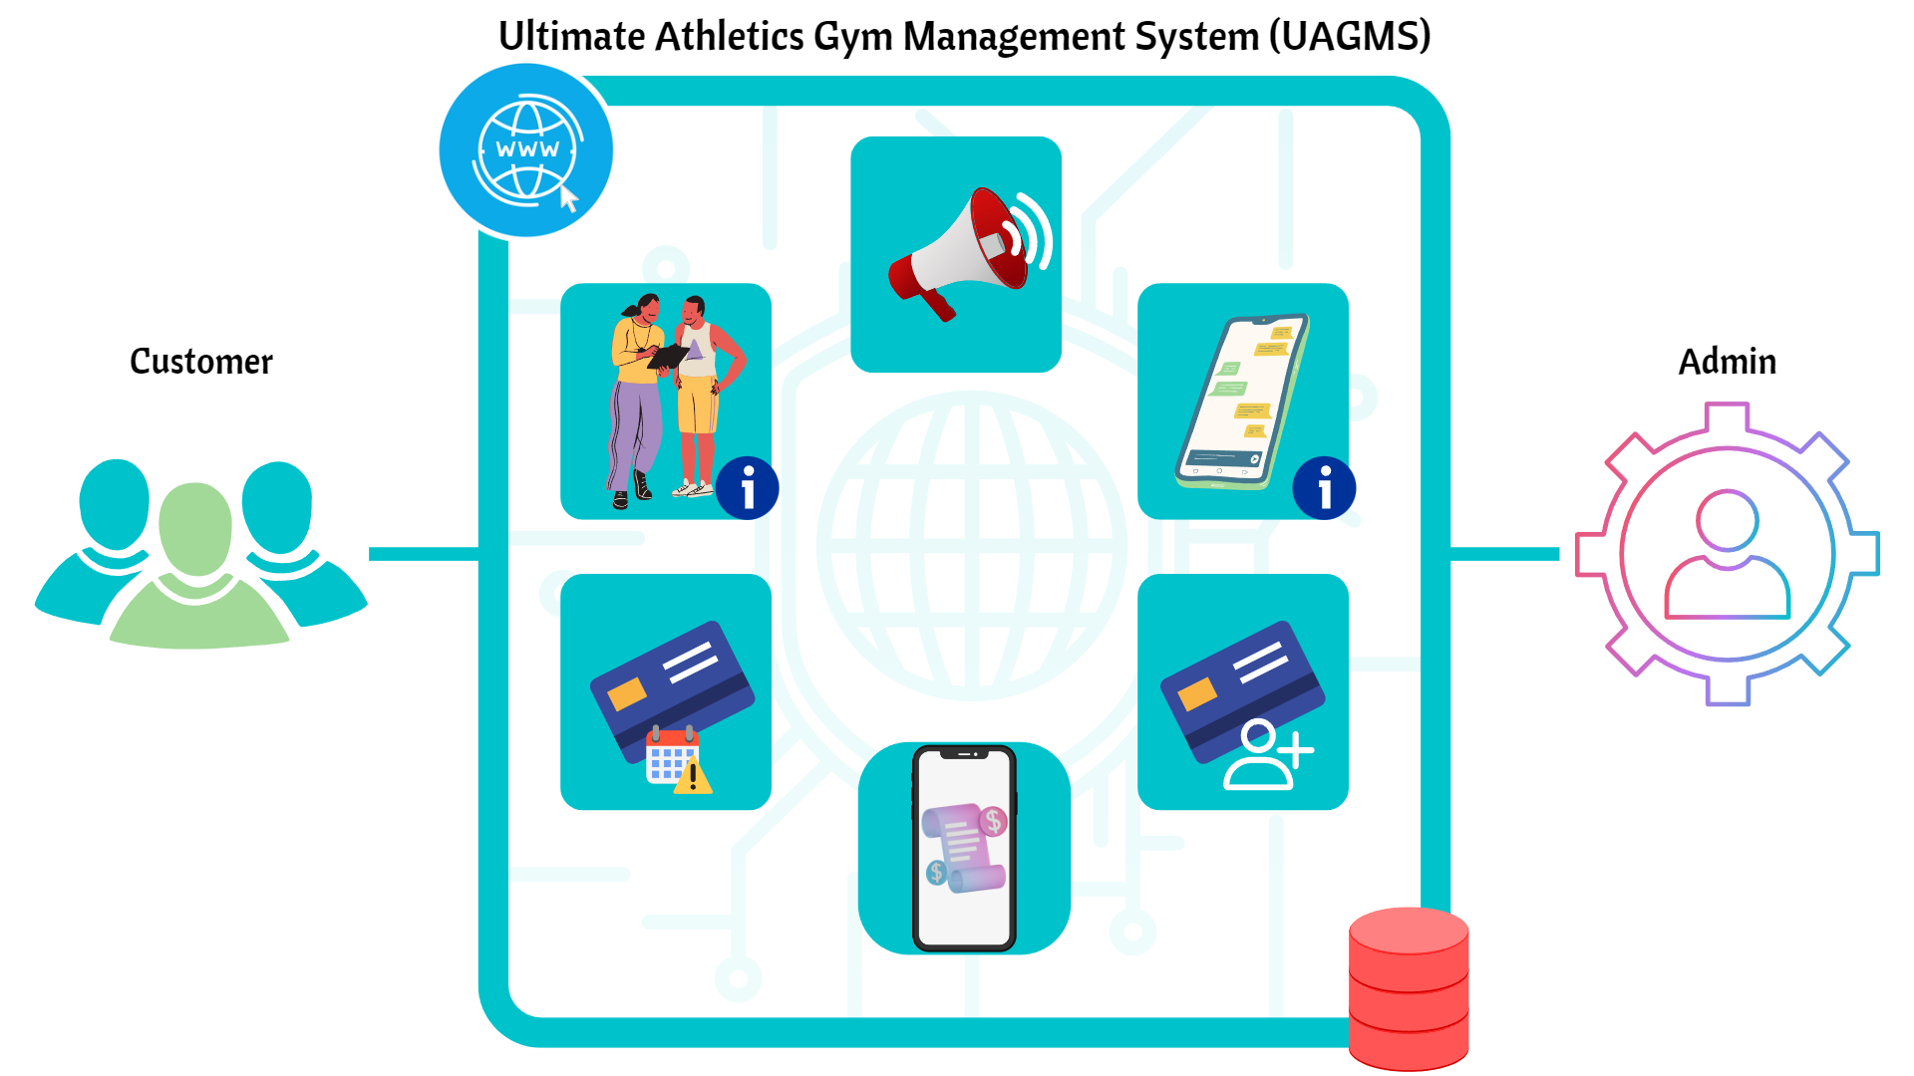

 

# TABLE OF CONTENTS

|  |  |
| --- | --- |
| **Contents** | **Pages** |
| **A. General Customer View**  **i. Before Login** |  |
| 1.0 Customer Website’s Header and Footer | **3 – 4** |
| 2.0 Homepage | **5 – 11** |
| 3.0 Login Page  **ii. After Login** | **12 – 13** |
| 4.0 Customer Website’s Header and Footer | **14** |
| 5.0 Join Membership | **15 – 16** |
| 6.0 Personal Tracker | **17** |
| 7.0 Payment | **18** |
| 8.0 Profile Page | **19** |
| **B. Administrator View** |  |
| 1.0 Logging In and Dashboard | **20 – 21** |
| 2.0 Membership | **22 – 23** |
| 3.0 Update Website | **24 – 25** |
| 4.0 Manage Member | **26** |
| 5.0 Progress Tracker | **27 – 29** |
| 6.0 Payment History | **30** |
| 7.0 My Profile | **31** |

1. **General Customer User View**

**i. Before Login**

* 1. **Customer Website’s Header and Footer**

The header and footer of the website are fixed elements that will always show at the top and bottom of each page, respectively. They feature navigation links that may be used to access the website's various page directories.

# Header

The Ultimate Athletic Gym Management System’s header is a Horizontal Navigation Bar Header that includes a logo, menu, and icons such as

* Ultimate Athletics Gym Logo - Navigates customer users to the Ultimate Athletics Gym Management System home page.
* Home – Navigates customer user to Ultimate Athletics Gym Management System’s home page.
* Why Us – Navigates customer user to the why us page.
* Program - Navigates customer users to the program page.
* Facilities - Navigates customer user to the facilities page.
* About Us – Navigates customer user to the about us page.
* Contact Us – Navigates user to the contact page.
* Profile Icon – A dropdown list containing a link to Login Page.

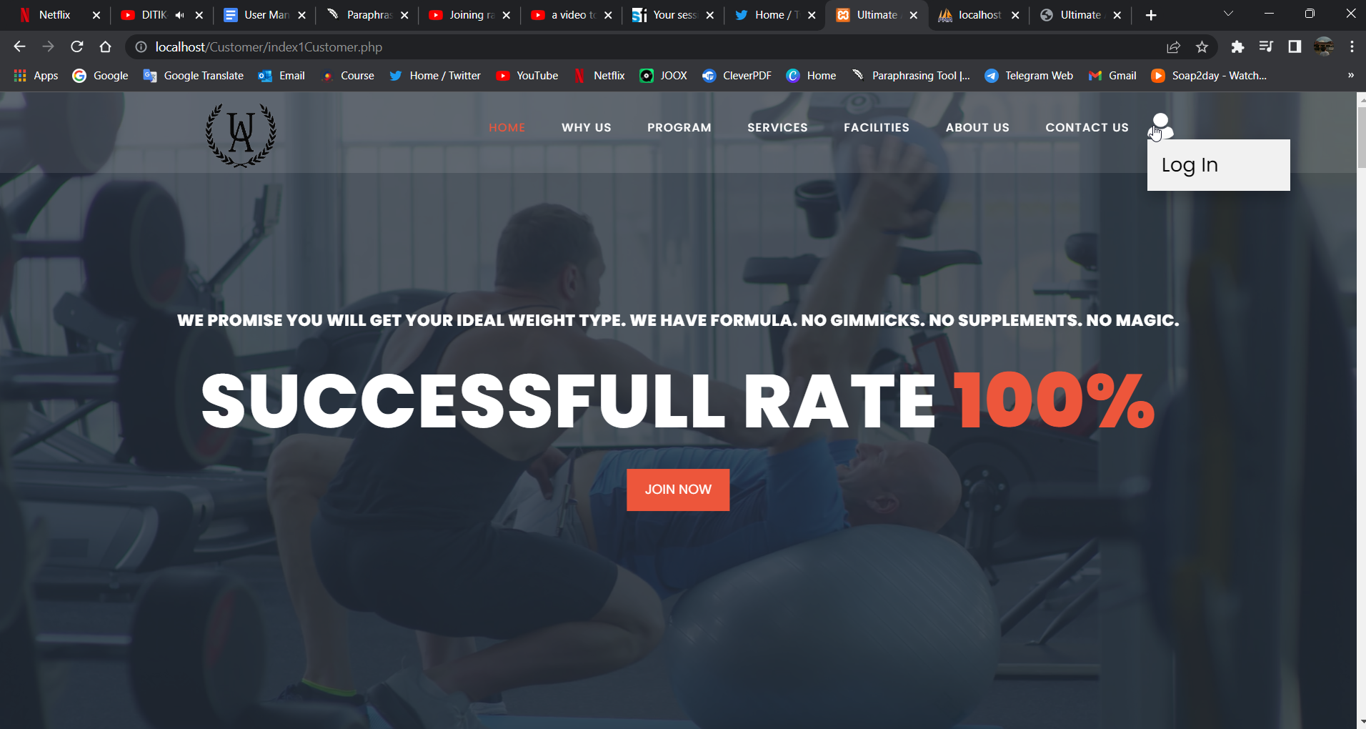

Figure 1: Ultimate Athletics Gym Management System’s Customer Website Header Before Login

# Footer

In the Ultimate Athletics Gym Management System’s web application, there is only 4 page that contains a footer. The footer is white and differs for the home page and tracker, membership, and payment page. For the home page, the footer only contains the copyright of the web application whereas the tracker, membership, and payment page contains a simple description and hyperlinks to navigate the customer user to the other social media web application, and also the copyright of the web application.

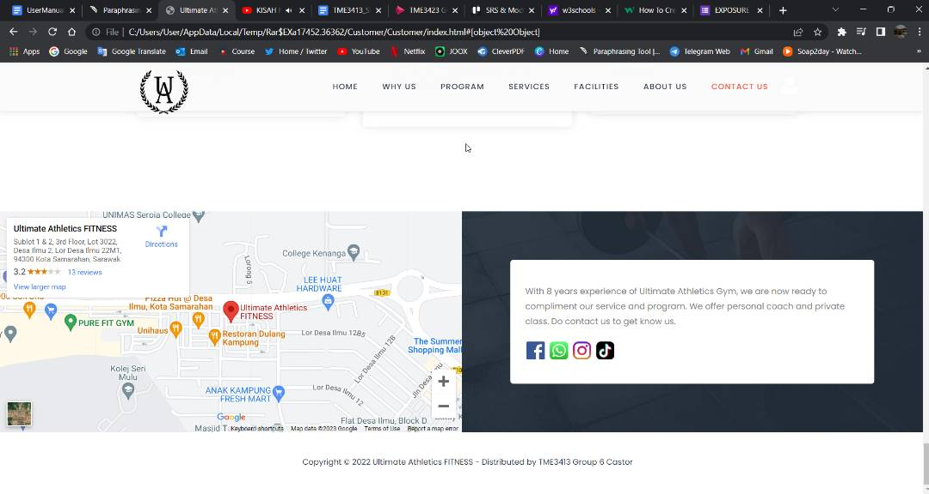

Figure 2: Ultimate Athletics Gym Management System’s Website Homepage Footer.

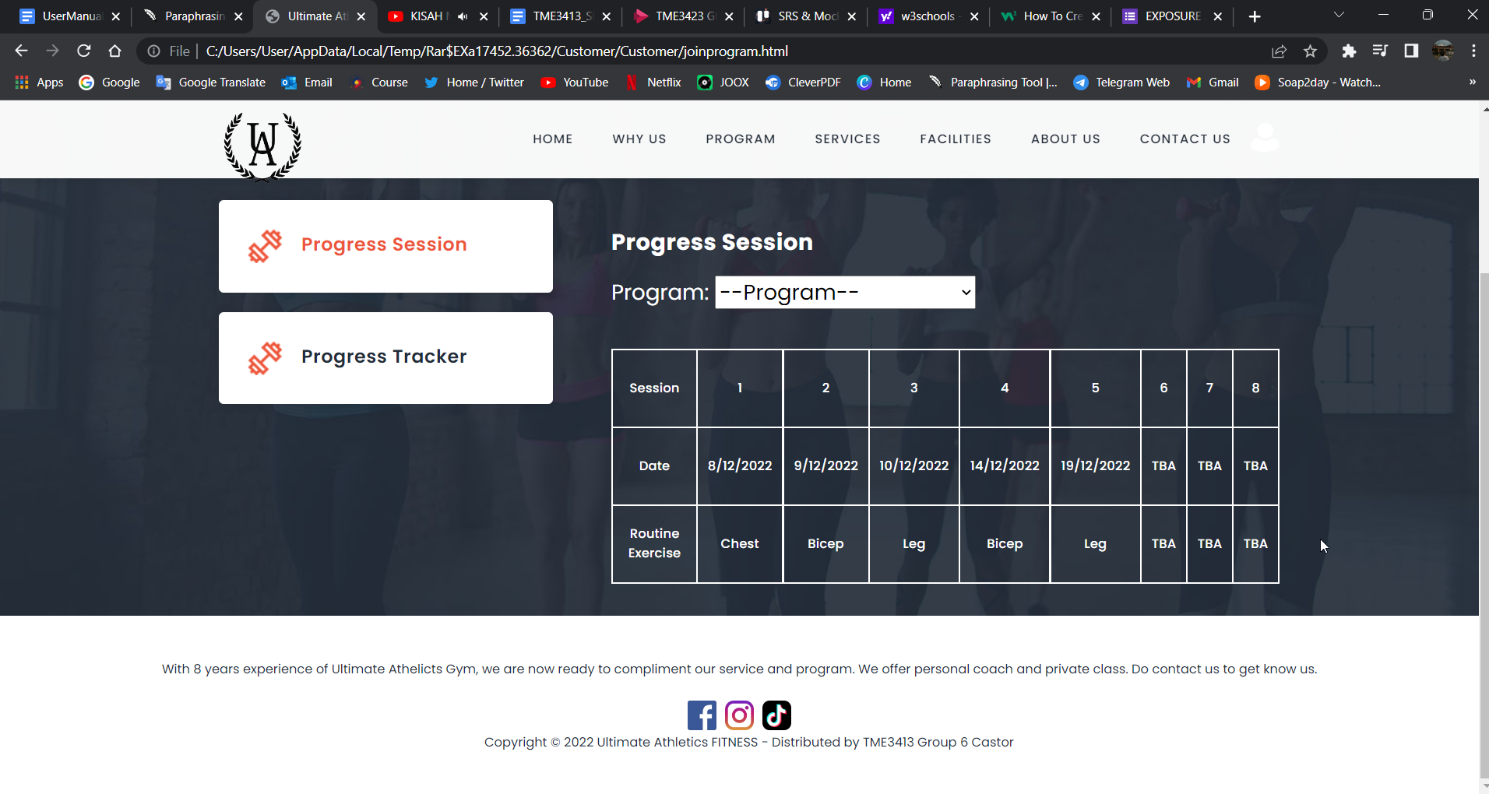

Figure 3: Ultimate Athletics Gym Management System’s Website Tracker page, Membership page, and Payment page Footer

# Homepage

The homepage is divided into 7 subsections:

* + 1. Home Section

The Ultimate Athletic Gym Management System contains a cinematic background, a commercial quotation, and a button that the user of the system may utilize to go through the login page.

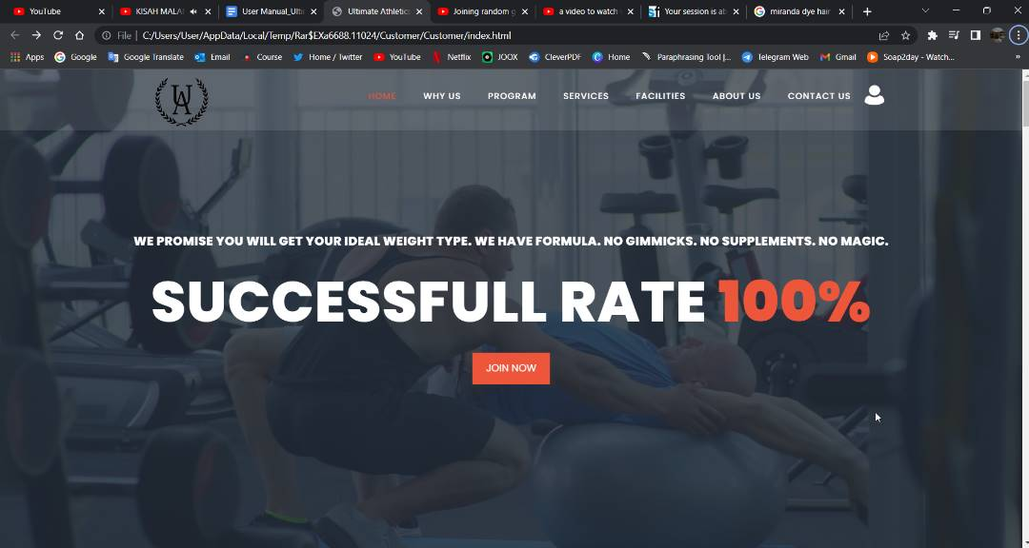

Figure 4: Homepage Section 1 - Home Section

* + 1. Why Us Section

This section explains why the client should pick the Ultimate Athletics Gym and what they can offer and produce for their customers.

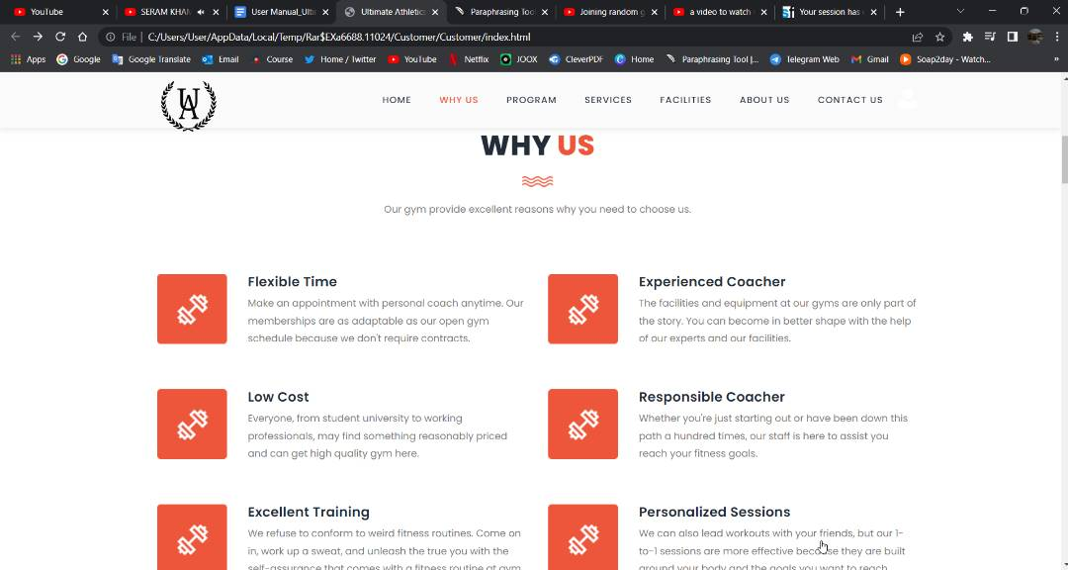

Figure 5: Homepage Section 2 - Why Us Section part 1

At the end of this section, there is a navigation button that will also redirect the customer user to the login page.

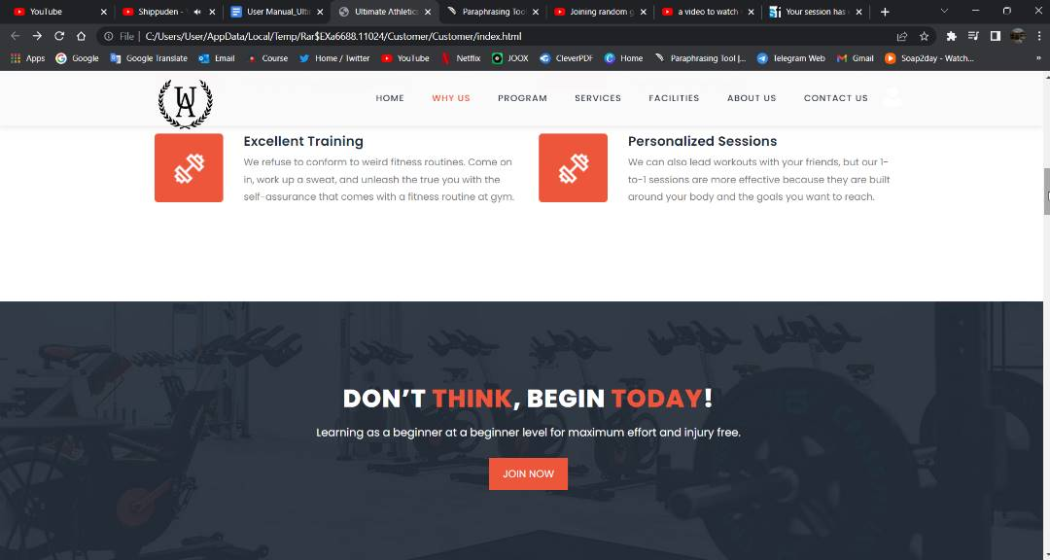

Figure 6: Homepage Section 2 - Why Us Section Part 2

* + 1. Program Section

This section shows the user the latest program that is available on the website. 3 programs are available and offered by the Ultimate Athletics Gym currently which are Eek! Online Program (EOP), Eek! Personal Program (EPP), and Zumba Classes, and at the end of the section, there is a navigation button directing the customer user to the login page. An example is per below:

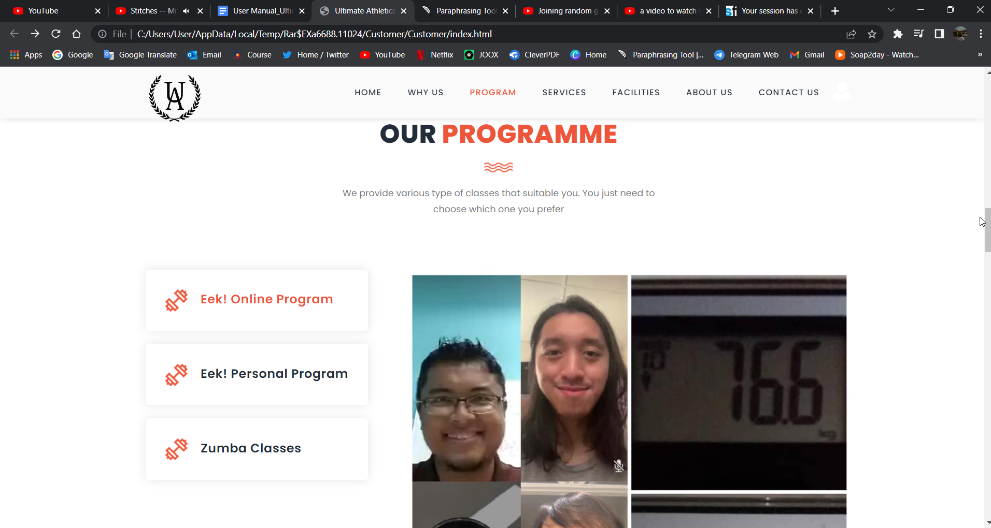

Figure 7: Homepage Section 3 - Program Section EOP Part 1

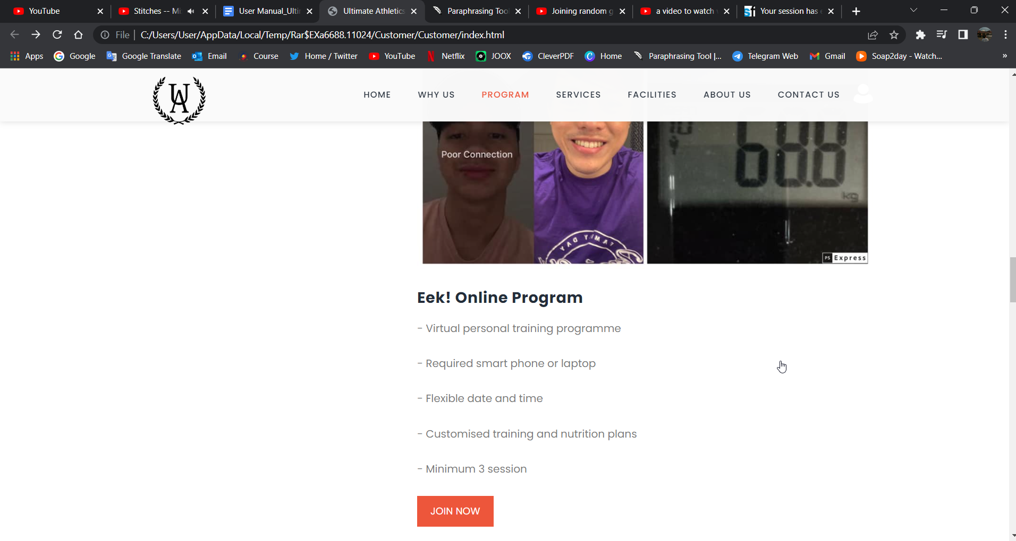

Figure 8: Homepage Section 3 - Program Section EOP Part 1

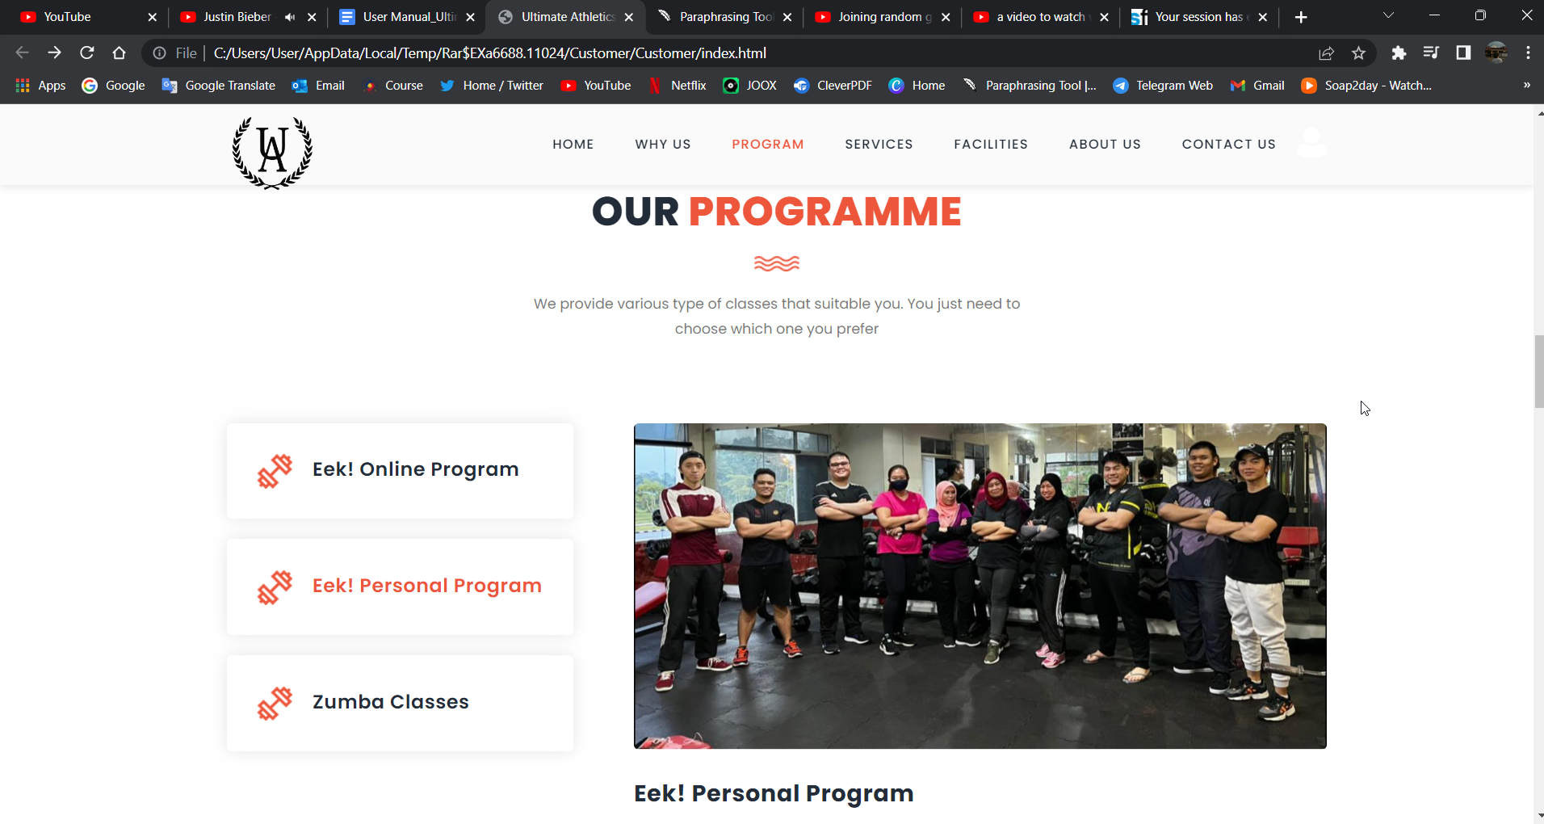

Figure 9: Homepage Section 3 - Program Section EPP Part 1

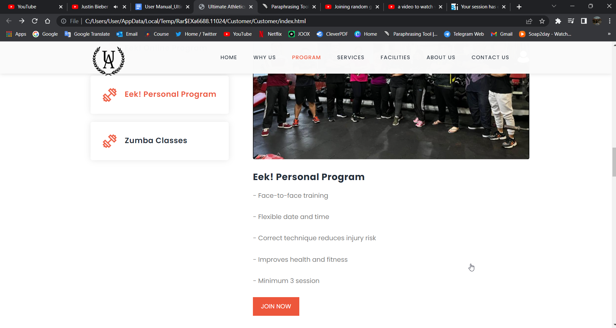

Figure 10: Homepage Section 3 - Program Section EPP Part 2

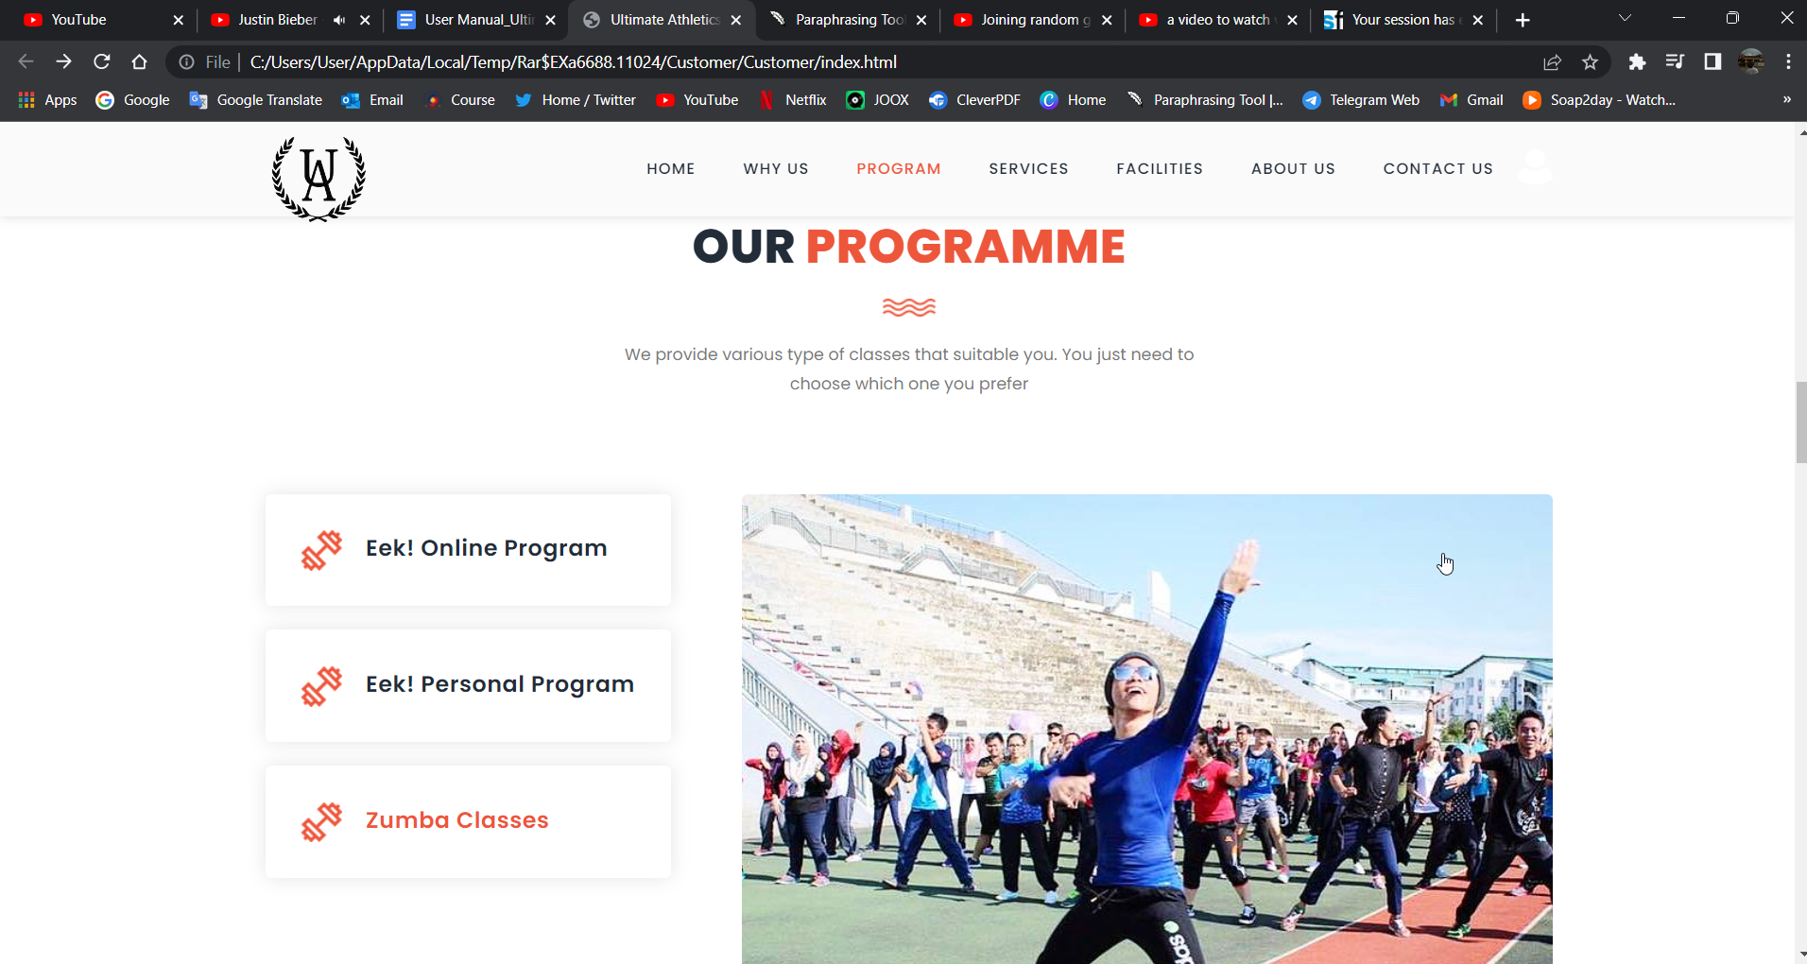

Figure 11: Homepage Section 3 - Program Section Zumba Classes Part 1

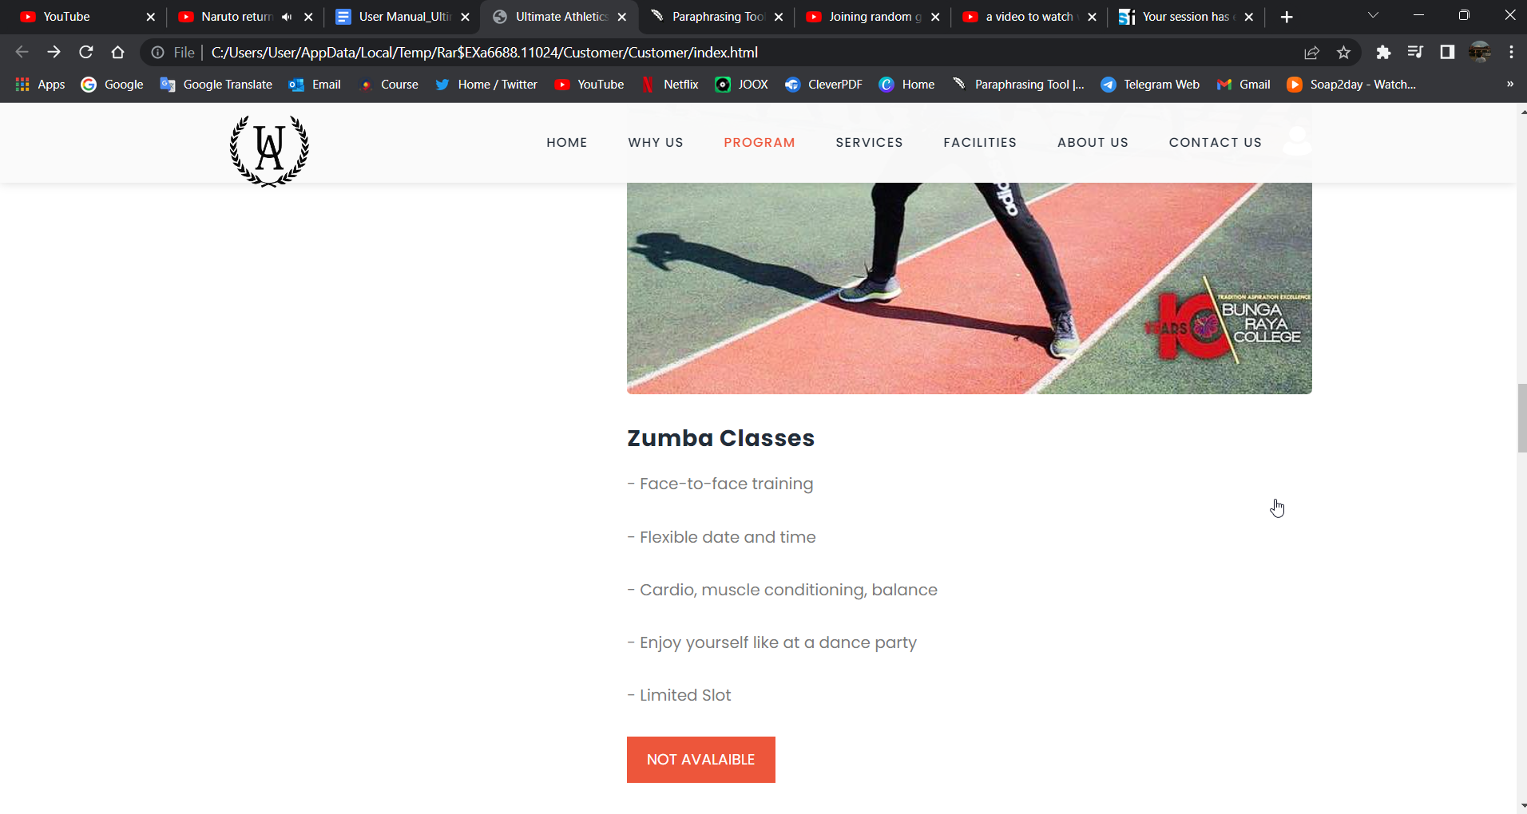

Figure 12: Homepage Section 3 - Program Section Zumba Classes Part 2

* + 1. Services Section

This section featured a table comparing all services given and offered by the Ultimate Athletics Gym Management System.

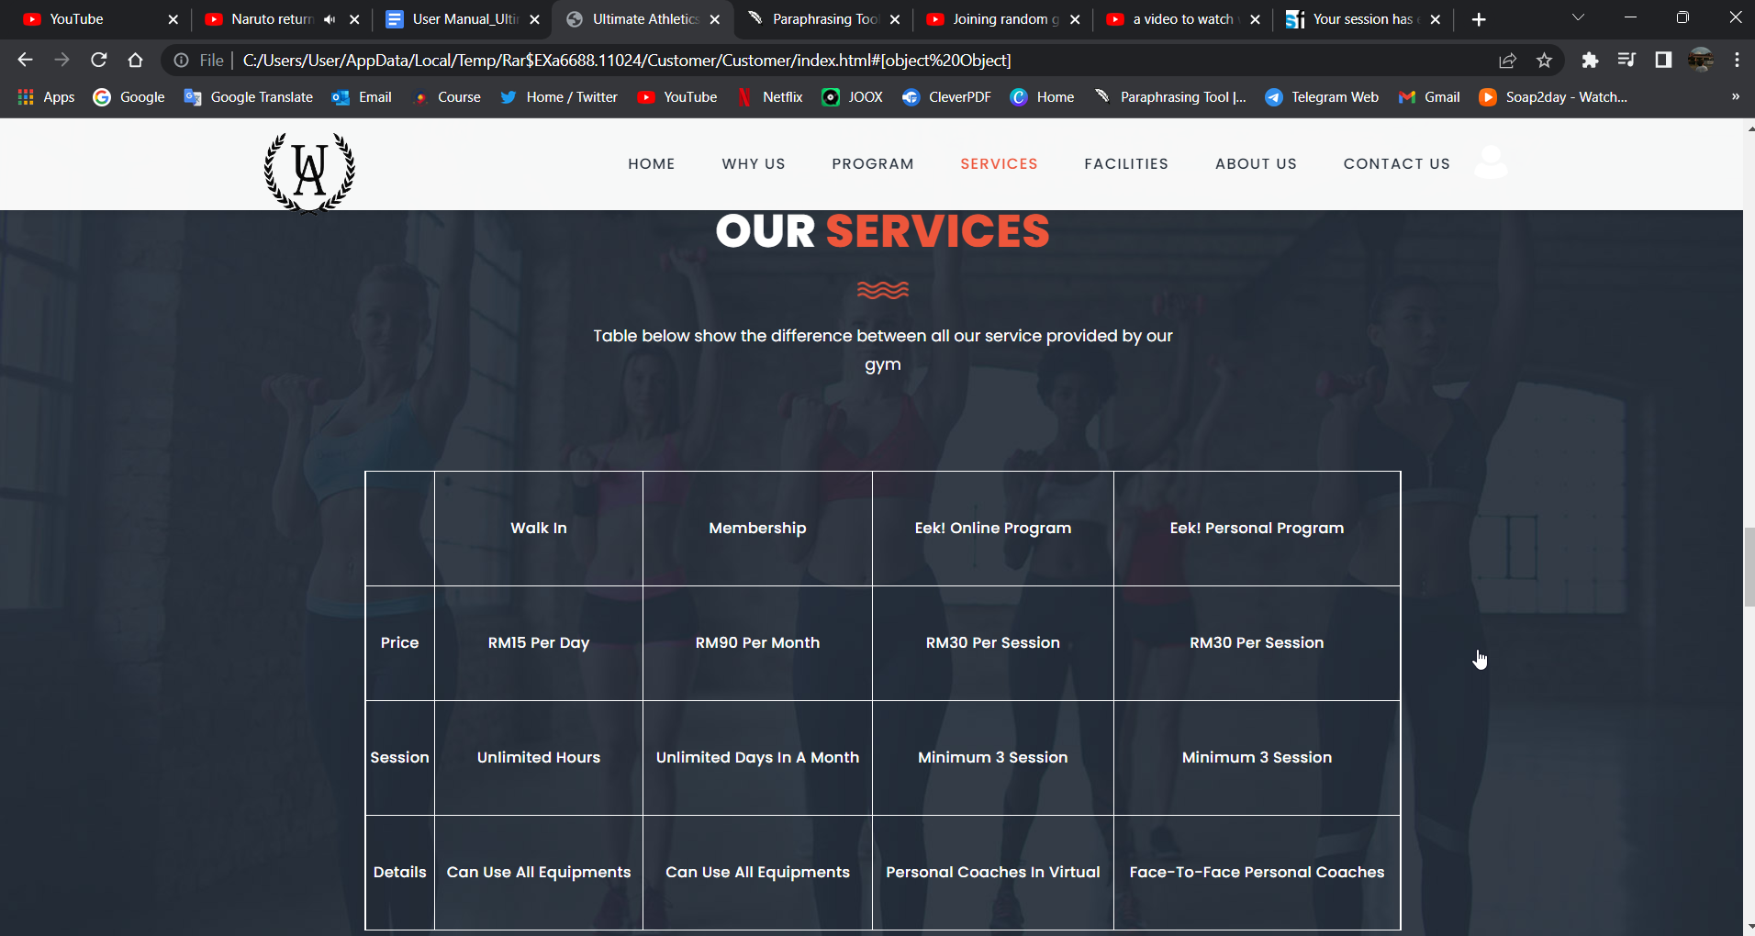

Figure 13: Homepage Section 4 – Services Section

* + 1. Facilities Section

This part included many slides with photographs of all the amenities accessible in the Ultimate Athletics Gym Management System. You may navigate through the slides by pressing the left and right buttons in the center-left and right of the picture.

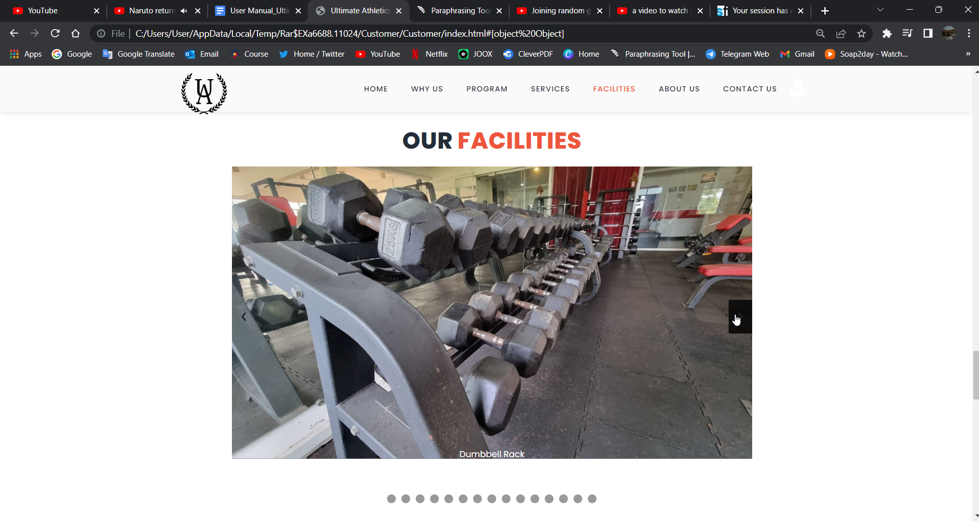

Figure 14: Homepage Section 5 – Facilities Section

* + 1. About Us Section

This section provided background information about the Ultimate Athletics Gym Management System company and staff members such as the founder, Mr. Ikrima, the Operational Manager and Head Coach, Mr. Qisthee, and the Assistant Coach, Mr. Waqiu.

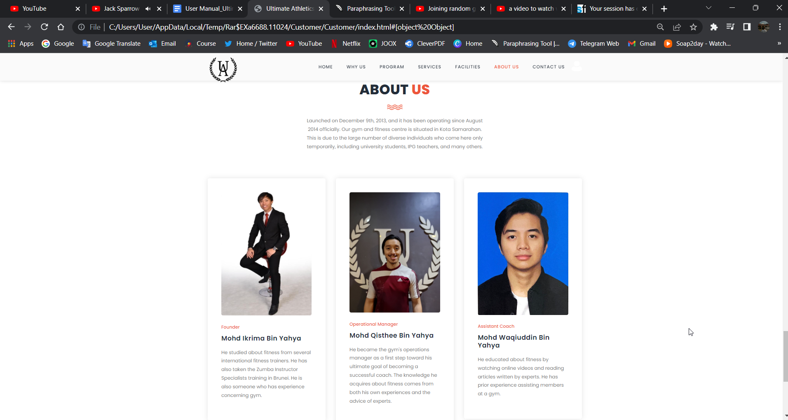

Figure 15: Homepage Section 6 – About Us Section

* + 1. Contact Us

This section provides the contact of the Ultimate Athletics Gym Management System such as the location, and social media like Facebook, Instagram, TikTok, and WhatsApp.

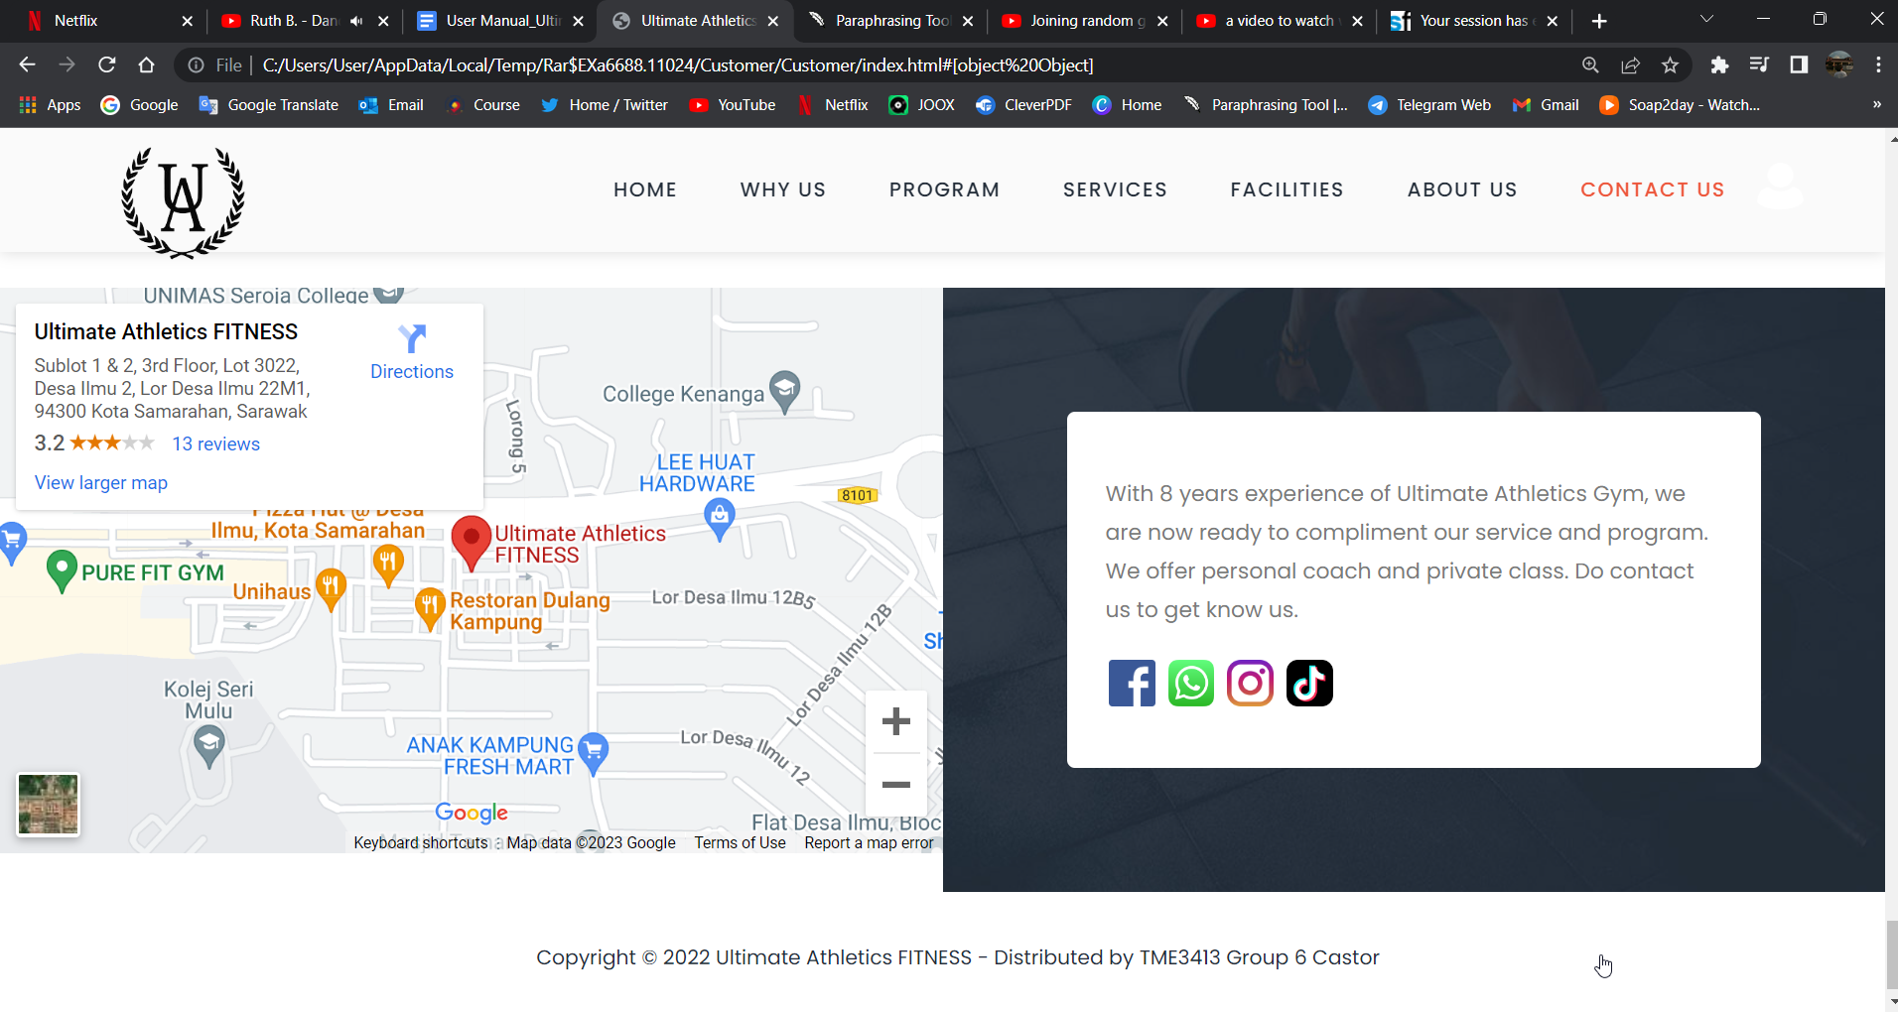

Figure 16: Homepage Section 7 – Contact Us Section

# 3.0 Login Page

To go to the login page, the customer user has to click on the profile icon next to the contact us menu where a vertical menu will pop up and the customer has to click the log in page where they will be redirected to the sign in page and this page there is a form where the user has to input their username and password to log in. If the user does not have the account yet, they have to



Figure 17: Homepage before Login- Login Page Option

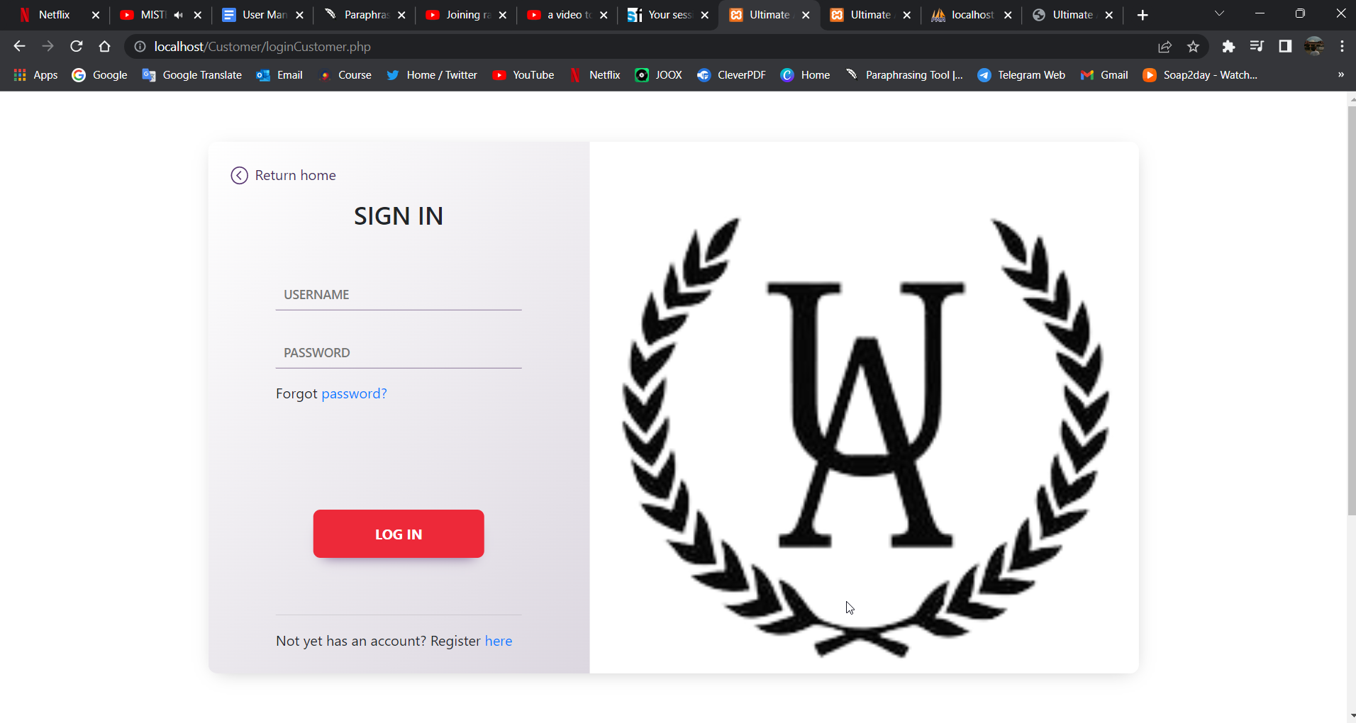

Figure 18: Login Page

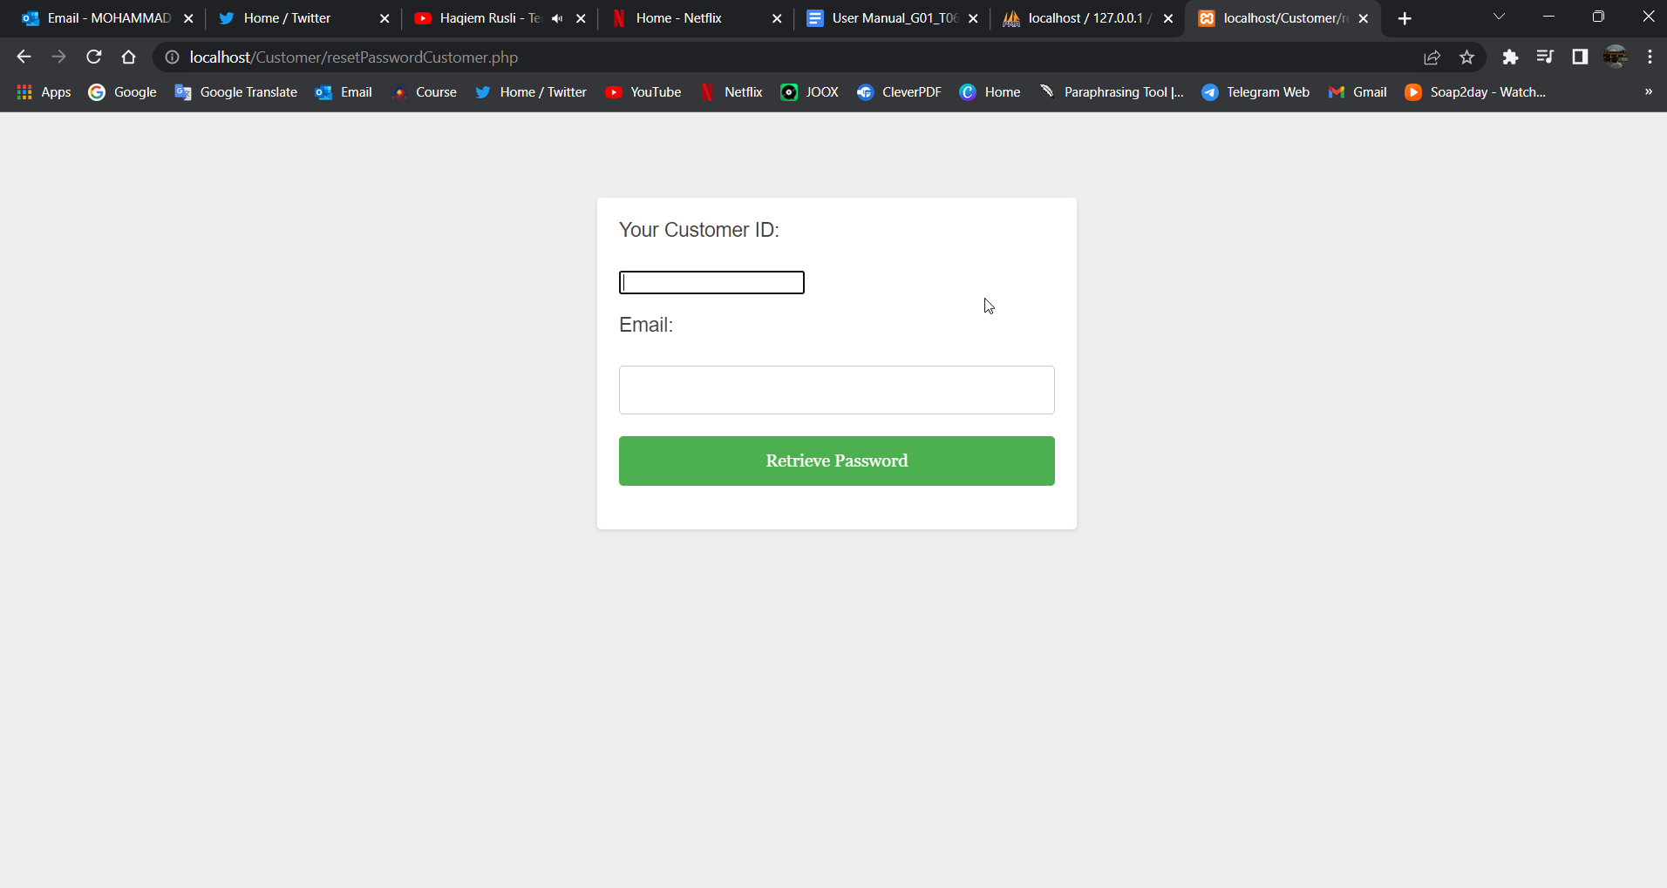

Figure 19: Forgot Password Page

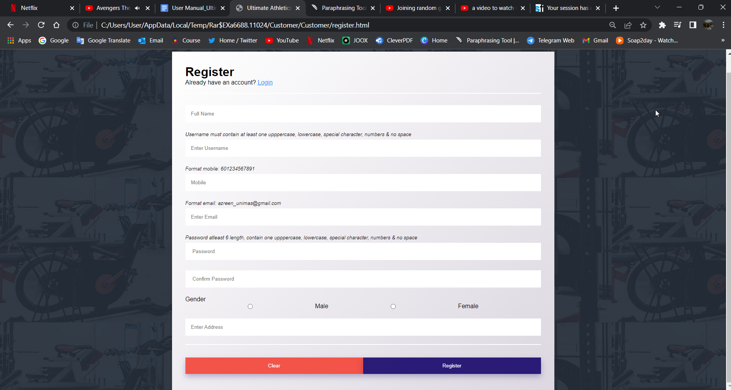

Figure 20: Registration Page

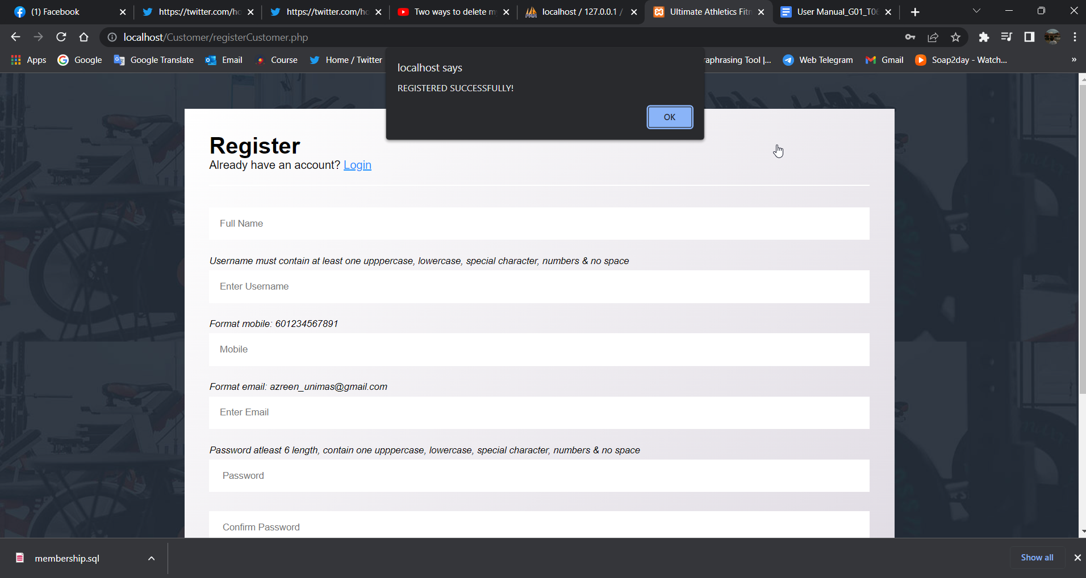

Figure 21: Notification of Successful Registration

**ii. After Login**

# 4.0 Customer Website’s Header, Footer, and Homepage After Login

The header, footer, and homepage of the customer website after login are the same as before login but the main difference is the menu that pops up after the profile icon next to the contact us menu is clicked.

# Header

The Ultimate Athletic Gym Management System's header after login is the biggest difference. After the user logs in and clicks the profile icon, the vertical menu that appears is vastly different from before the login, although the footer remains unchanged. The example is as per below:

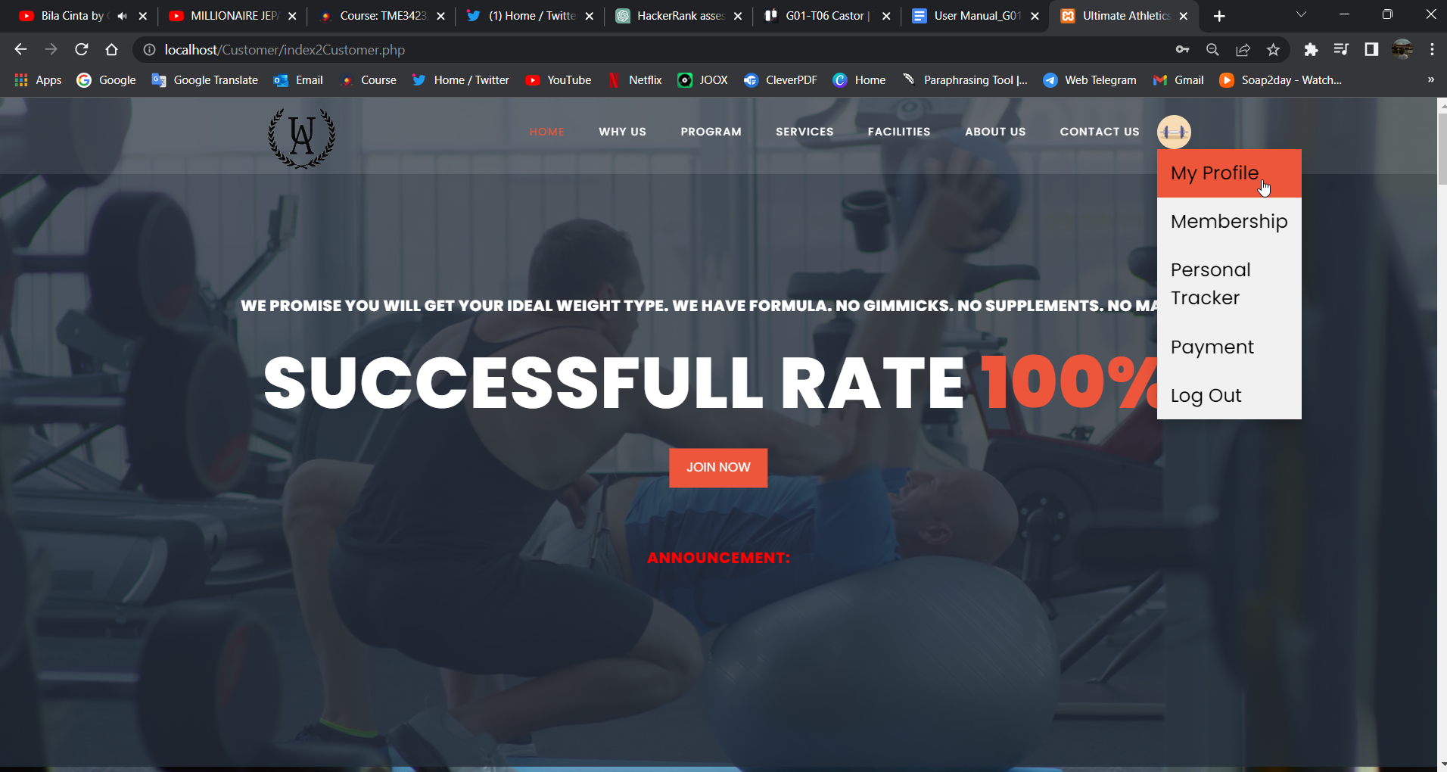

Figure 22: Ultimate Athletics Gym Management System’s Customer Website Header After Login

# 5.0 Join Membership

After login, if the customer user wants to apply for membership, then they have to fill out the form application for membership by clicking the profile icon and then select the “Join Membership” option. It will redirect you to the Form Application page. This application form can also be accessed by the customer by clicking the “Join Now” button at

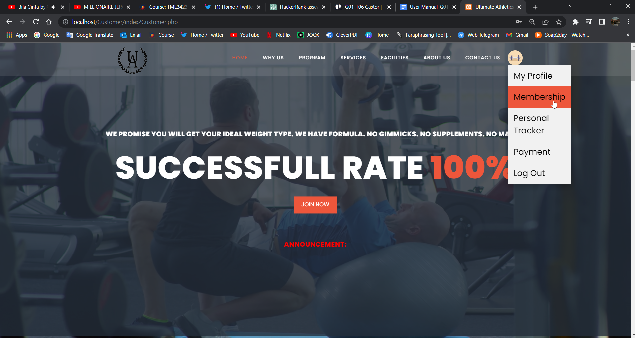

Figure 23: Homepage after Login - Join Membership

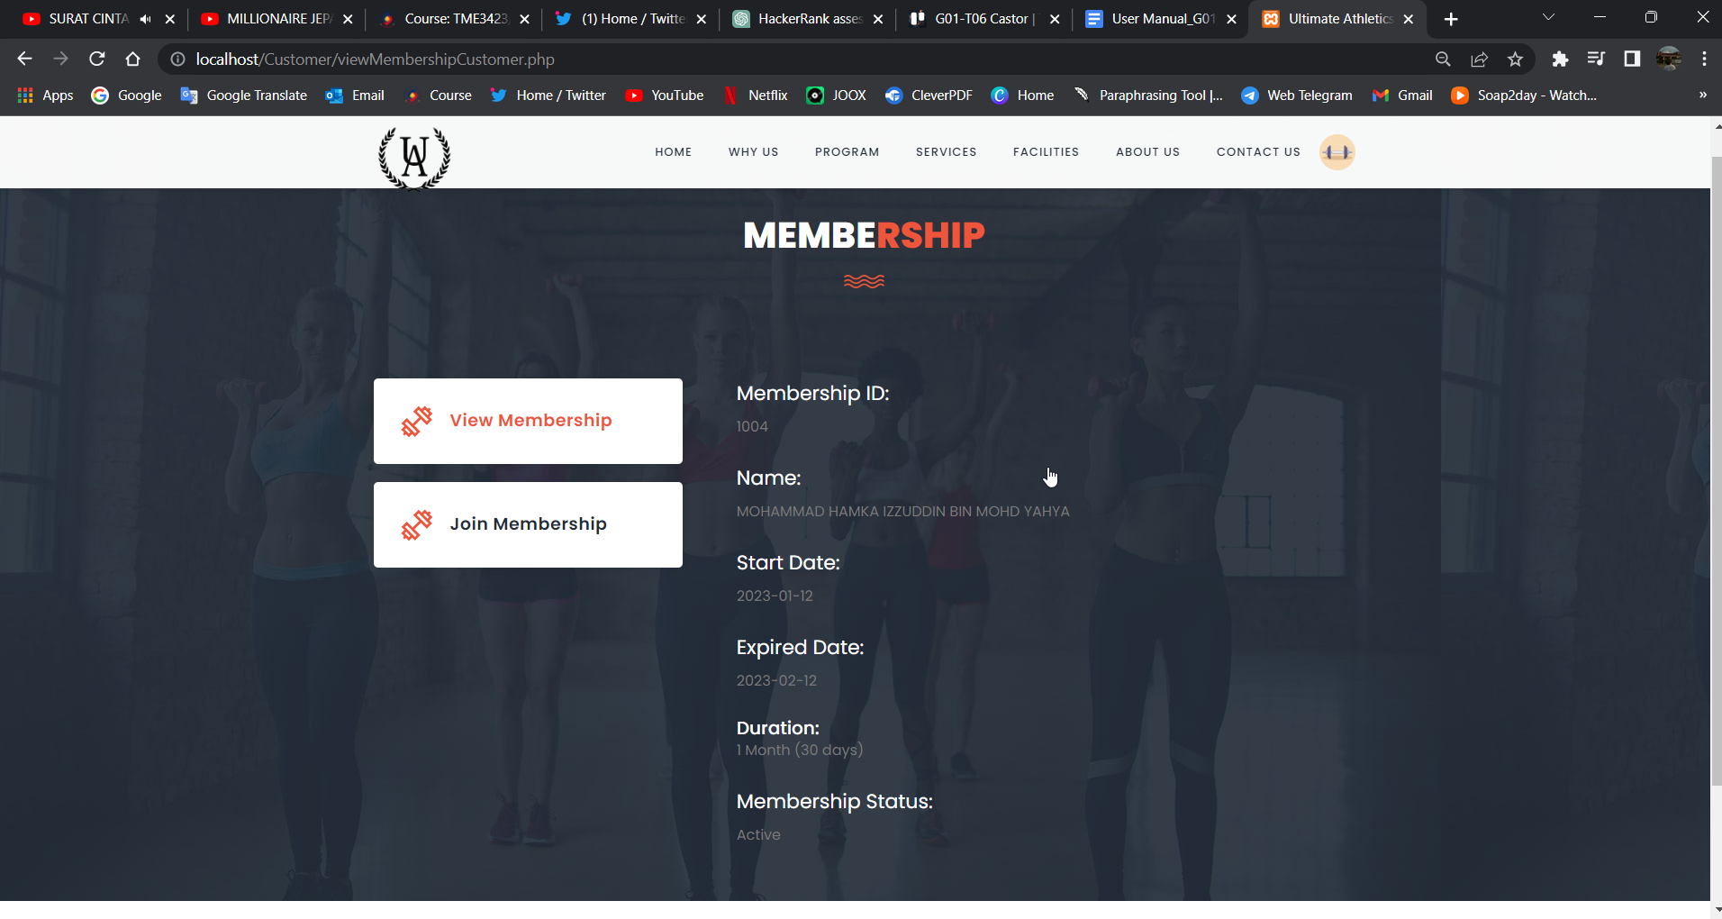

Figure 24: Membership Page



Figure 25: Join Now Button at Home section, and Why Us section at Homepage

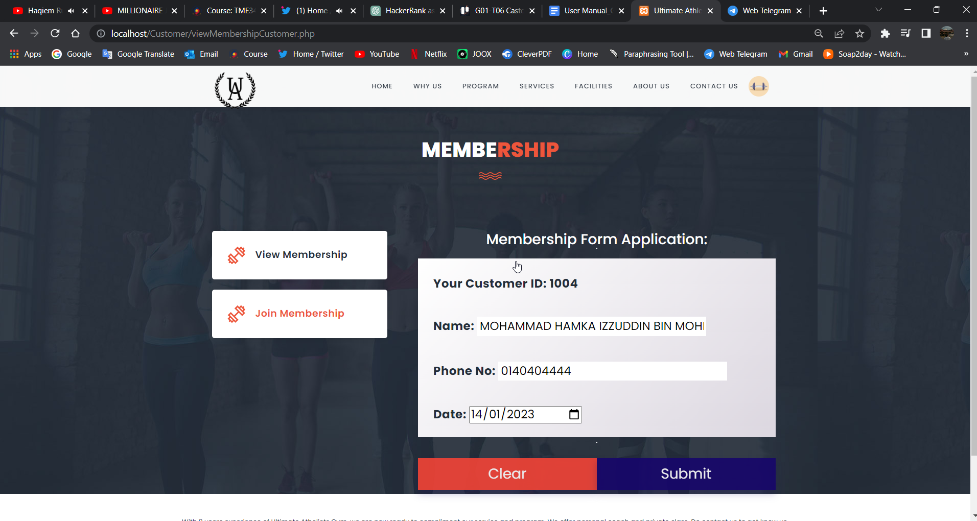

Figure 26: Form Application Page to Join Membership

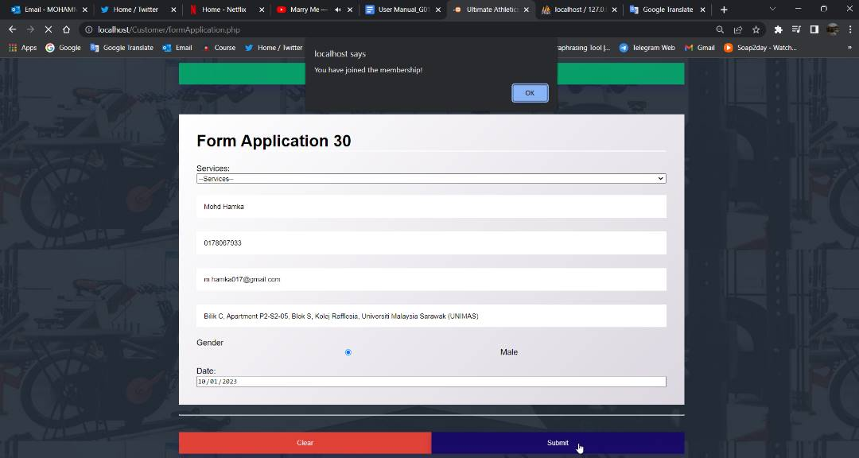

Figure 27: Form Application Page - Notification for successfully membership application

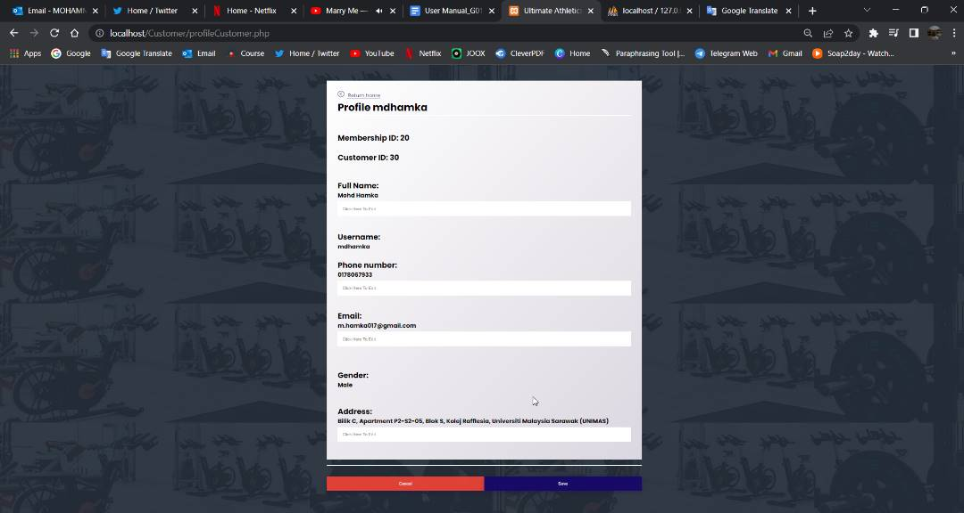

Figure 28: Customer Profile Page - Membership ID appeared when the customer user has successfully applied for the membership

# 6.0 Personal Tracker

One of the best and unique features of the Ultimate Athletic Gym Management System is that it features a tracker to keep and track the customer progress and session record for the customer muscle growth and development. To utilize this feature, the customer user will just have to choose whether they want to see the progress session or progress tracker by clicking the button either the progress session button or the progress tracker button. In the Progress session, they can display the customer progress session table by selecting the program while for the Progress Tracker table, the customer user will have to select the program and session.

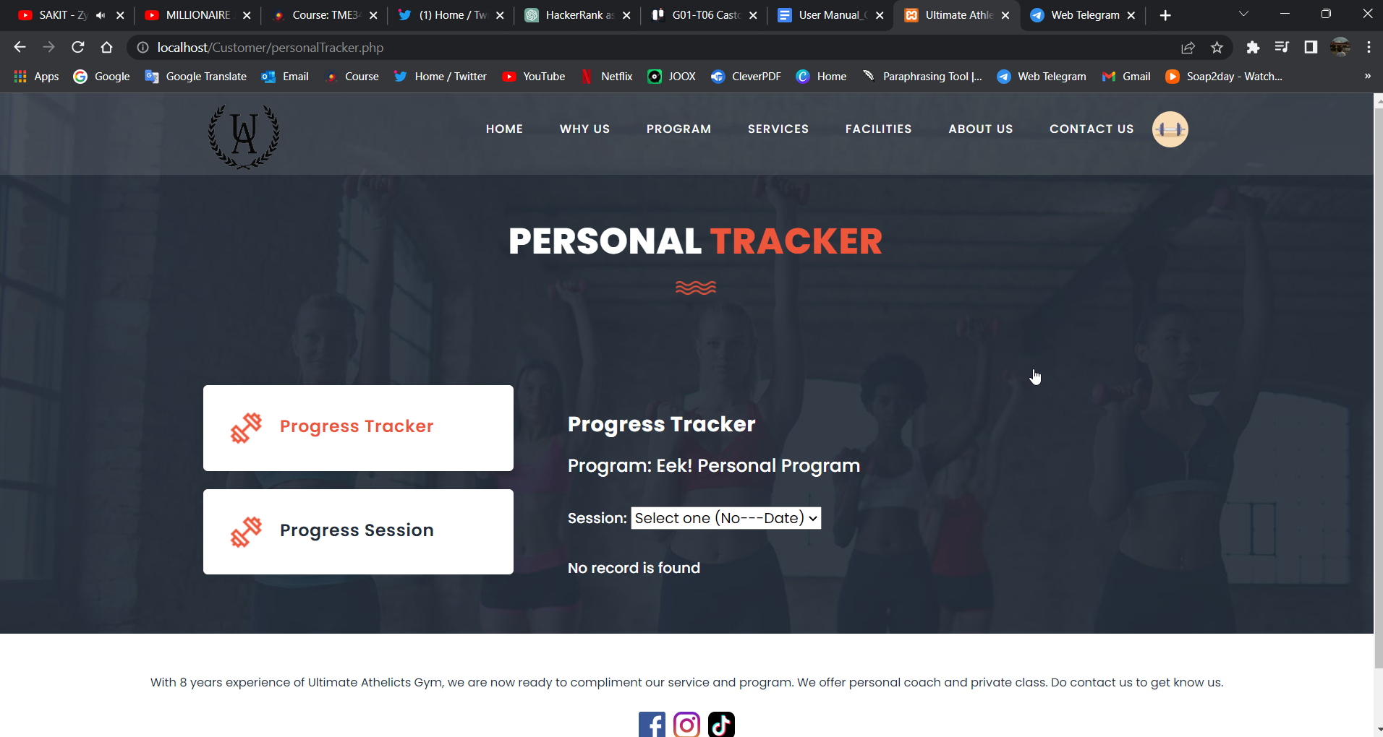

Figure 29: Personal Tracker Page - Progress Session

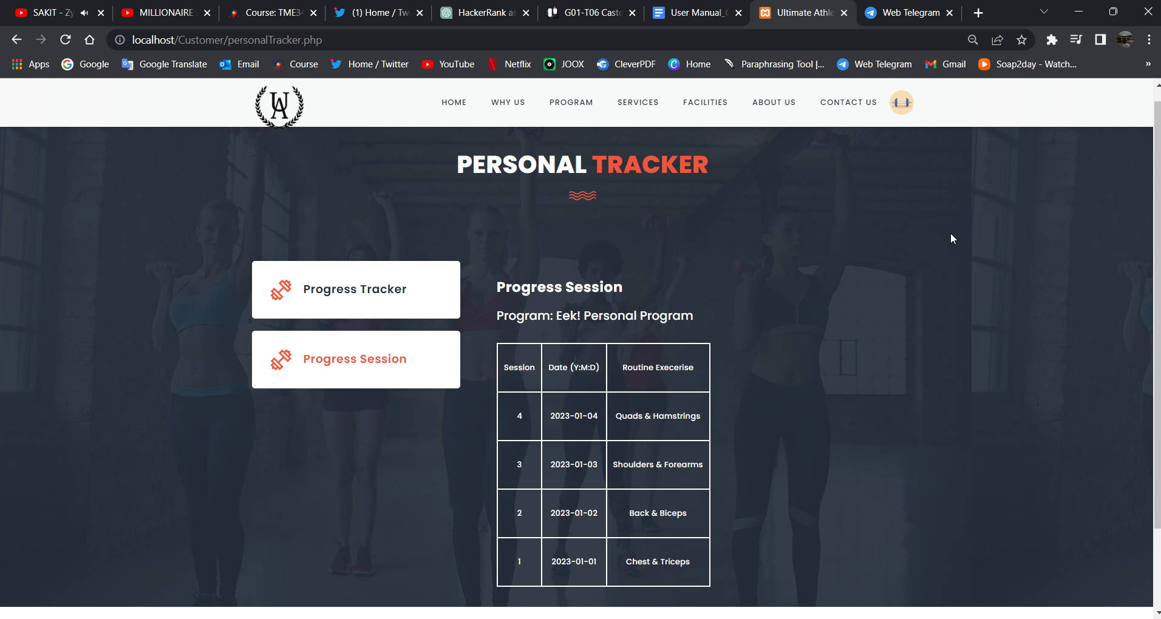

Figure 30: Personal Tracker Page - Progress Session

# 7.0 Payment

Customer user can access the payment page by clicking the profile icon next to the contact us menu on the header and then select the payment option. The customer user then will be redirected to the payment page where the customer users are prompted to 2 payment methods of online banking and pay cash payment method. Selecting “Online Banking”, the customer user will have to submit the order without any necessary online payment. For the Stripe Payment choice, users will be directed to the payment gateway to input their stripe payment information for the transaction process. Once a successful order is made, a new tab showing the order confirmation details will be displayed to the user.

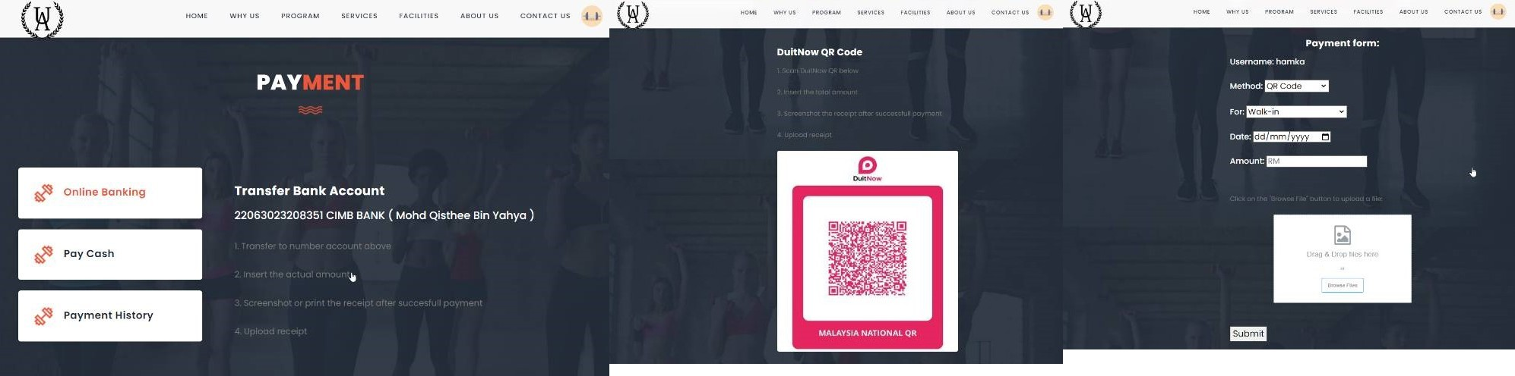

Figure 31: Payment Page - Online Banking

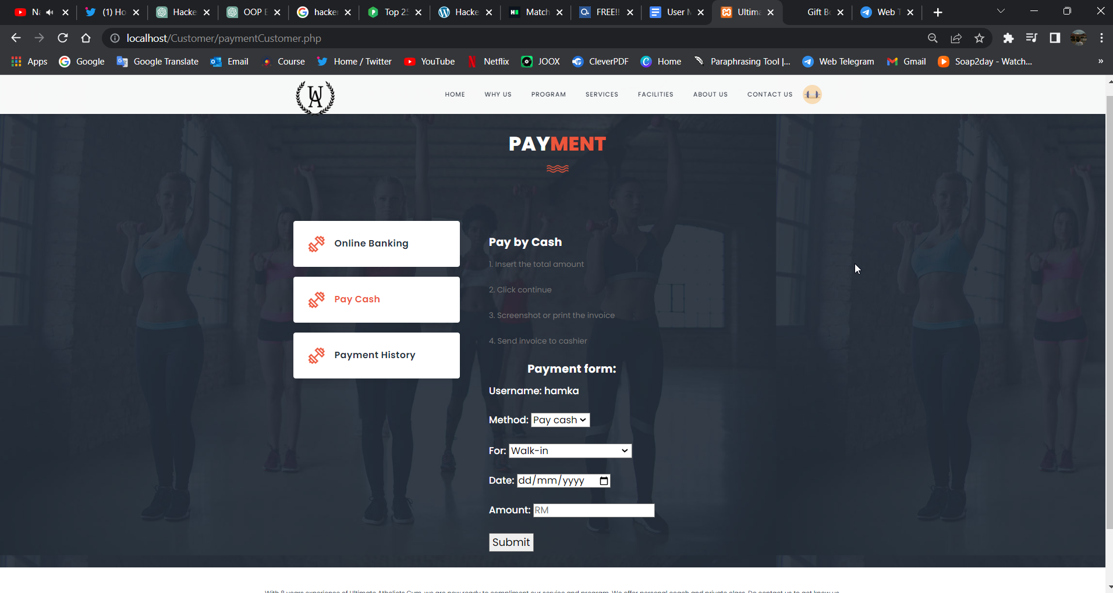

Figure 32: Payment Page - Pay Cash

# 8.0 Profile Page

Once the customer users have registered an account, they will be able to access and view the profile that they have created and updated their profile.

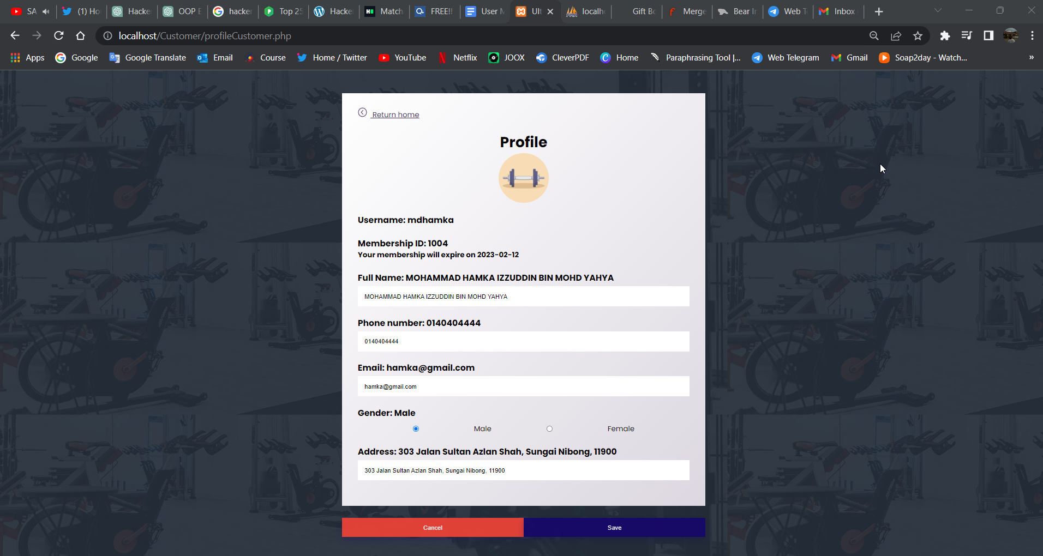

Figure 33: Customer Profile Pag

# Administrator View

**1.0 Logging In and Dashboard Page**

When a user enters a website URL and clicks search, they are sent to the administrator login page. Use the email address ikrima@gmail.com, qisthee@gmail.com, and qiu@gmail.com to get access, and the password must be abc123. To access the Administrator side of the Ultimate Athletic Gym Application, the administrator must provide this exact address.

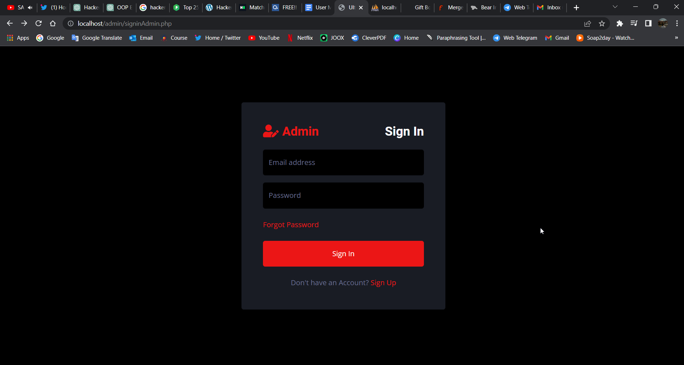

Figure 34: Administrator Login Page - Sign In Page

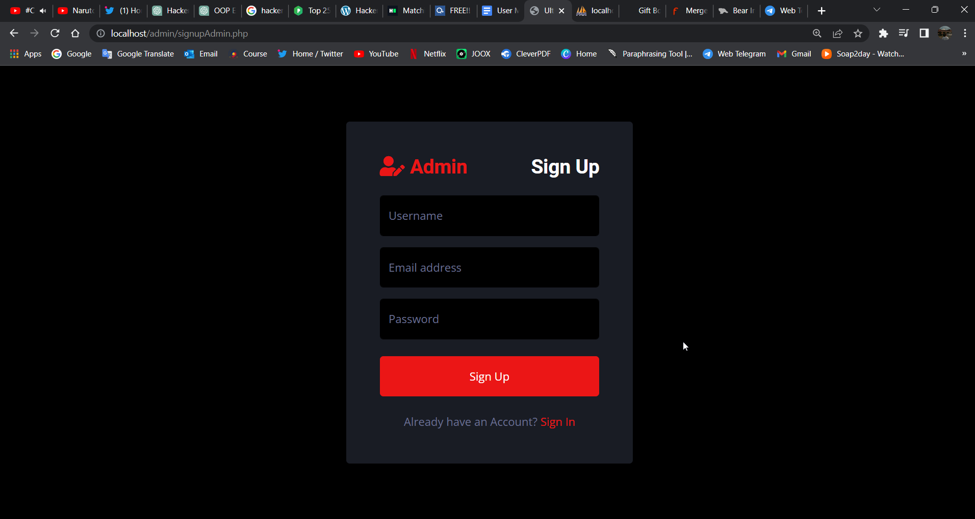

Figure 35: Administrator Login Page - Sign Up Page

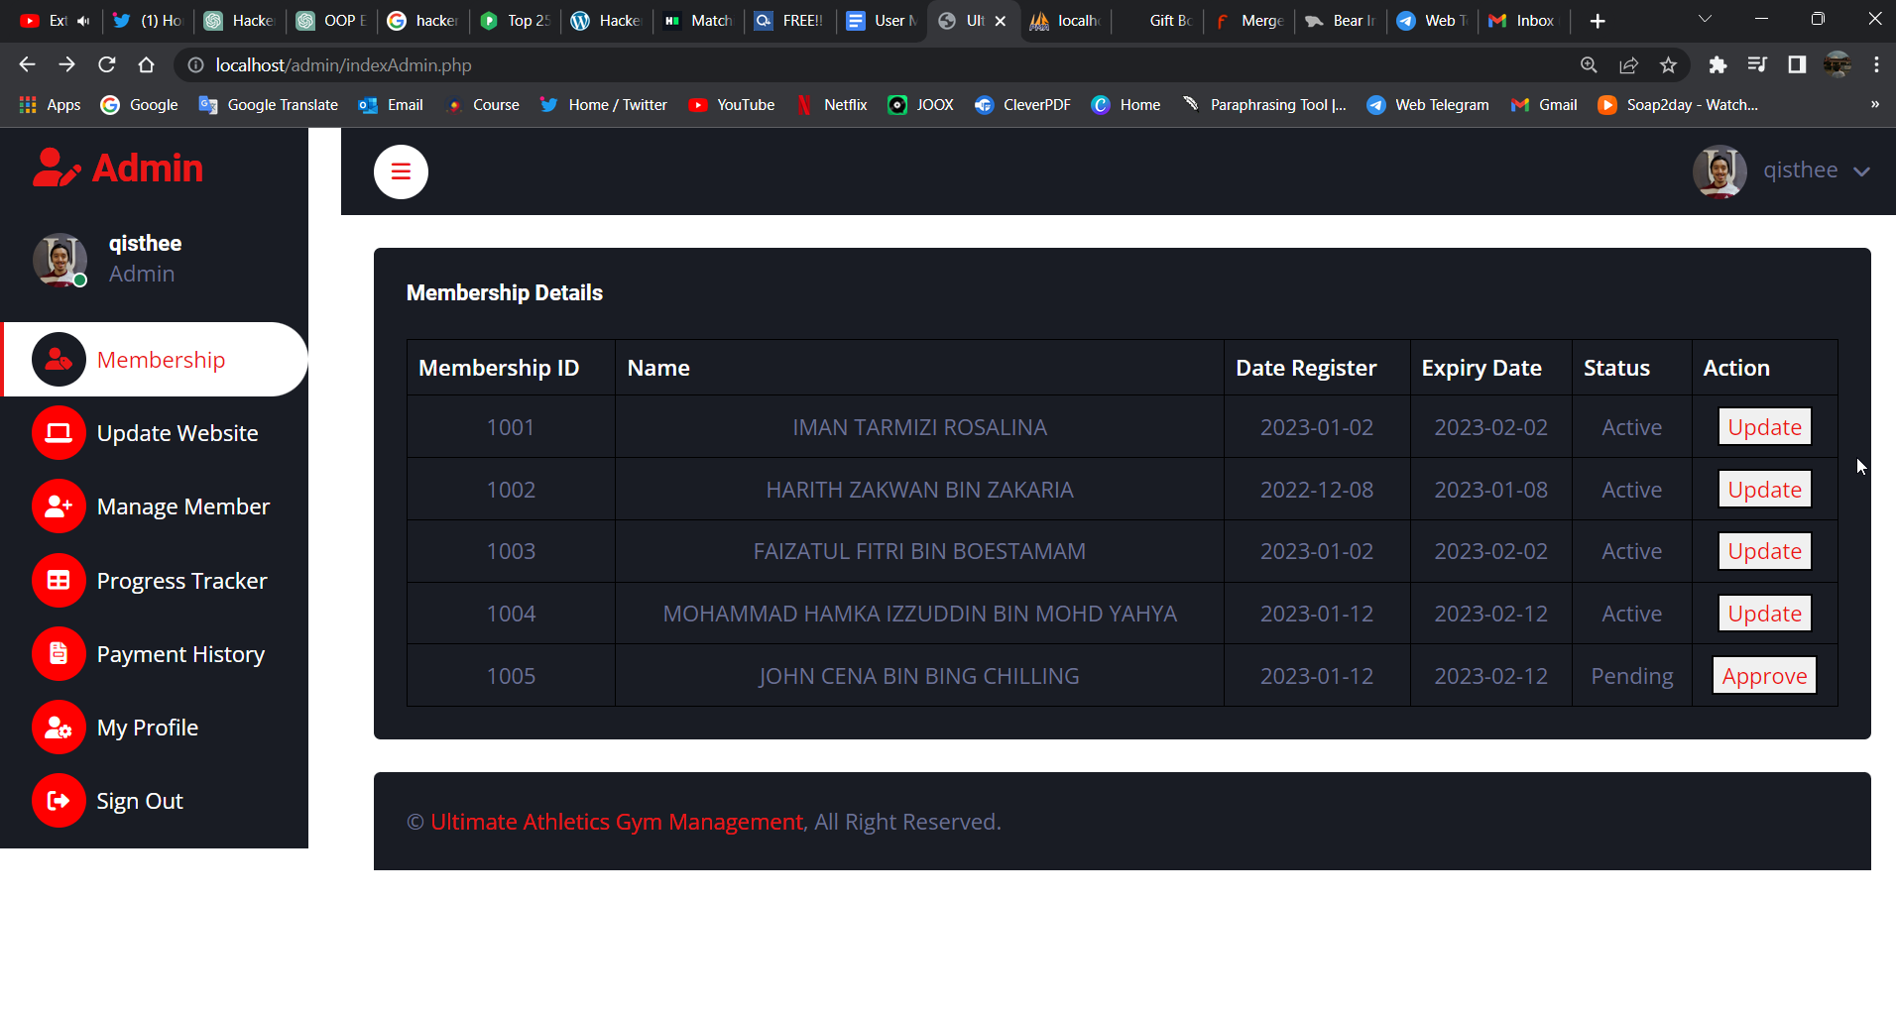

Figure 36: Main Dashboard Page for the Administrator

Once on the dashboard page, the administrator can use the sidebar to move across the administrator website. The admin will be redirected to the dashboard page that displays the first section of the administrator dashboard, the membership page, by clicking on the Admin label at the top left of the dashboard page.

# 2.0 Membership

The membership ID, name, registration date, expiration date, status (active, inactive, or pending), and the action that has to be performed for the customer's membership (such as updating and approving it) are all displayed on the membership information page.

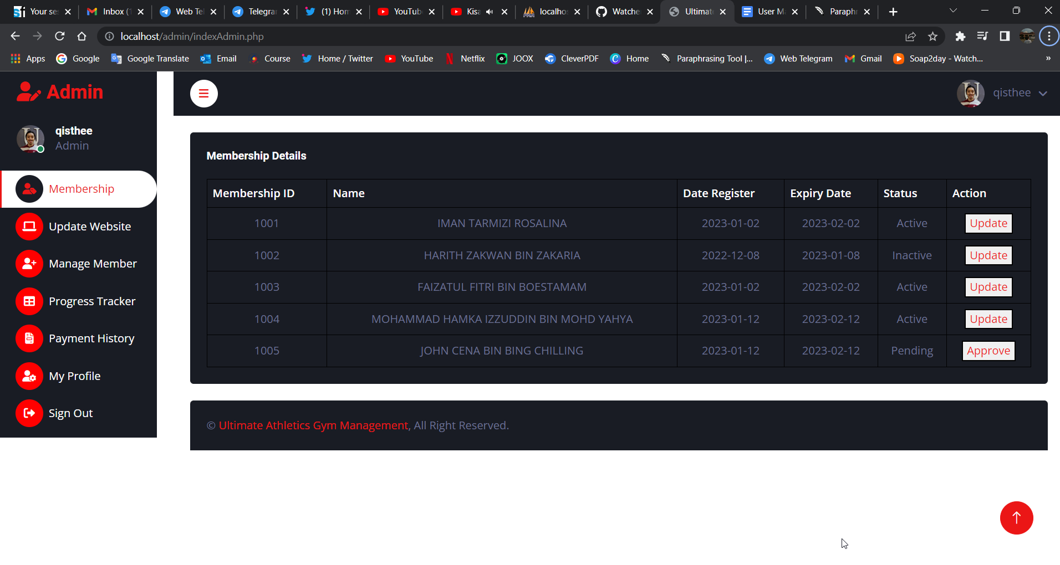

Figure 37: Membership

The admin user will then be redirected to the update membership details page of the membership and manage member page for the approved member whose status is active or inactive and those members who are still not approved yet they will be redirected to the payment history page to approve their membership after the admin user has validated and verify the customer payment.

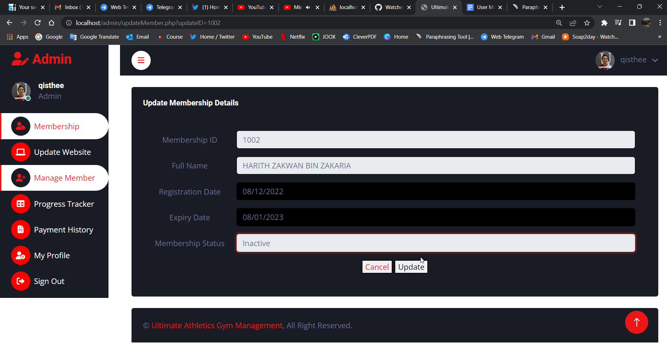

Figure 38: Update Membership Details  
  
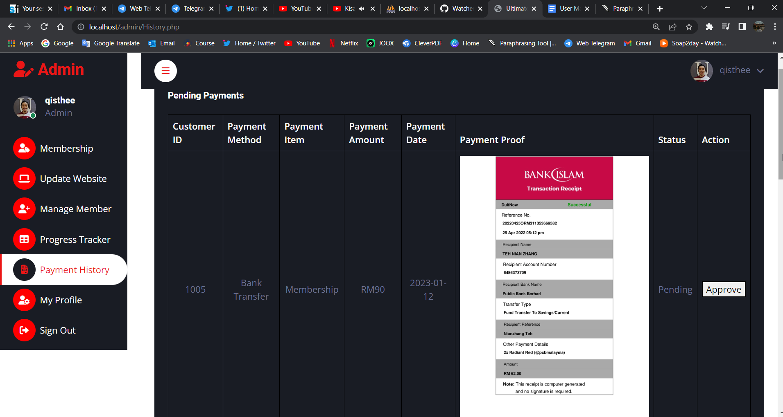  
Figure 39: Approve Membership at Payment History Page

# 3.0 Update Website

Clicking on the Update Website on the sidebar will redirect the admin user to the Update Website which consists of website info such as Programs, Services, Facilities, About Us, and Contact Us with action to be taken like updating the Website Info.

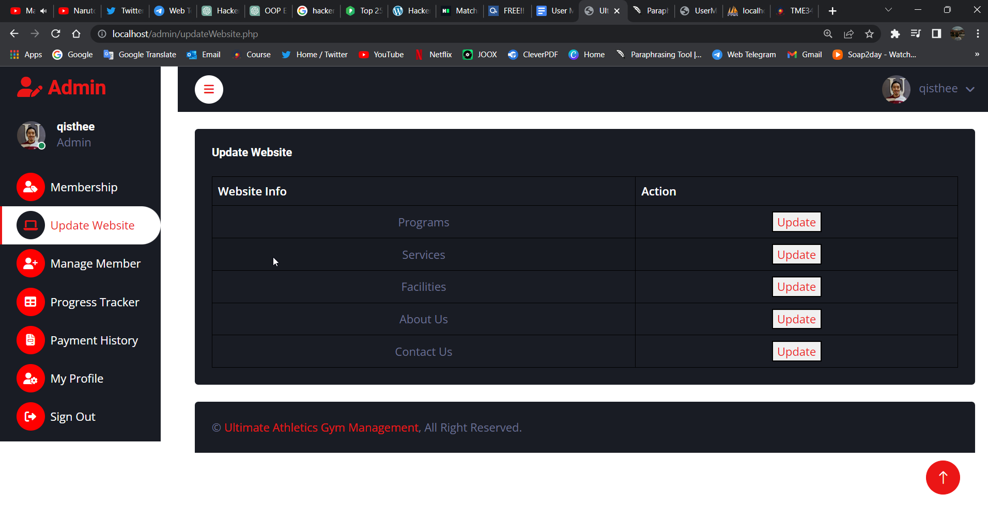

Figure 40: Update Website Page

The admin user will be sent to the Program Update page of the Update Website if they decide to update a particular piece of information, let's say programs, and this page will provide a table of the currently available and unavailable program as well as a form to update the program but they have to choose and select the program first before they want to update it. It should be noted that only the program ID cannot be modified or altered.

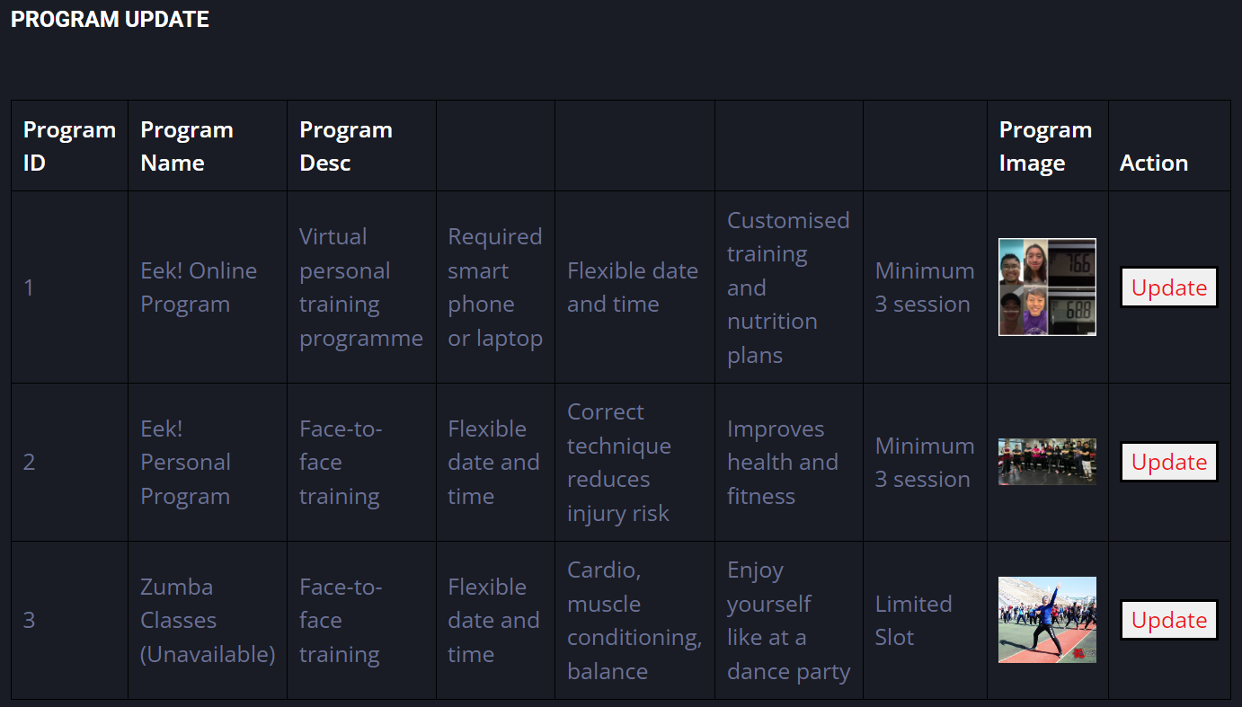

Figure 41: Update Website Page - Program Update part 1

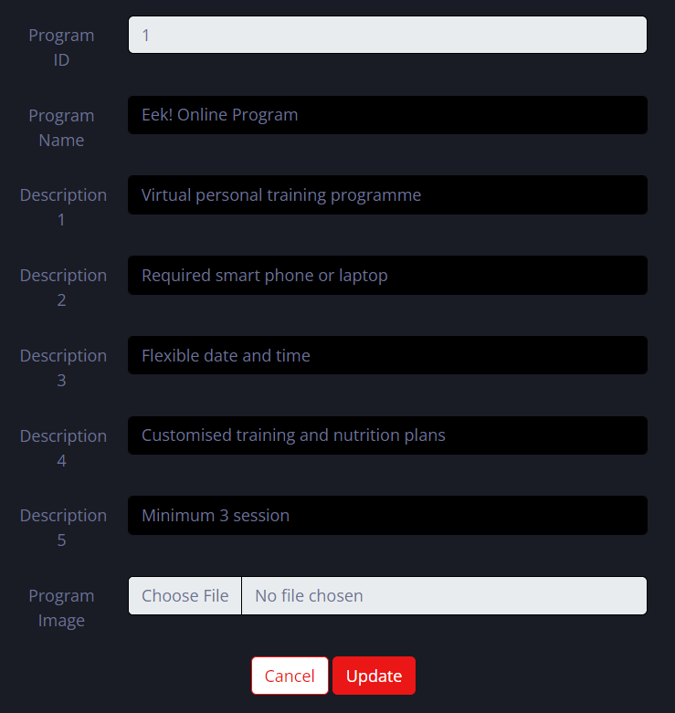

Figure 42: Update Website Page - Program Update part 2

The same is applicable for the other website information, such as Services, Facilities, About Us, and Contact Us, where users must first pick the website information they wish to edit before selecting further website information from a table.

# 4.0 Manage Member

Clicking on the Manage Member on the sidebar will redirect the admin user to the Manage Member page which consists of the Customer Details table of members to be updated. website info such as Programs, Services, Facilities, About Us, and Contact Us with action to be taken like updating the Website Info.

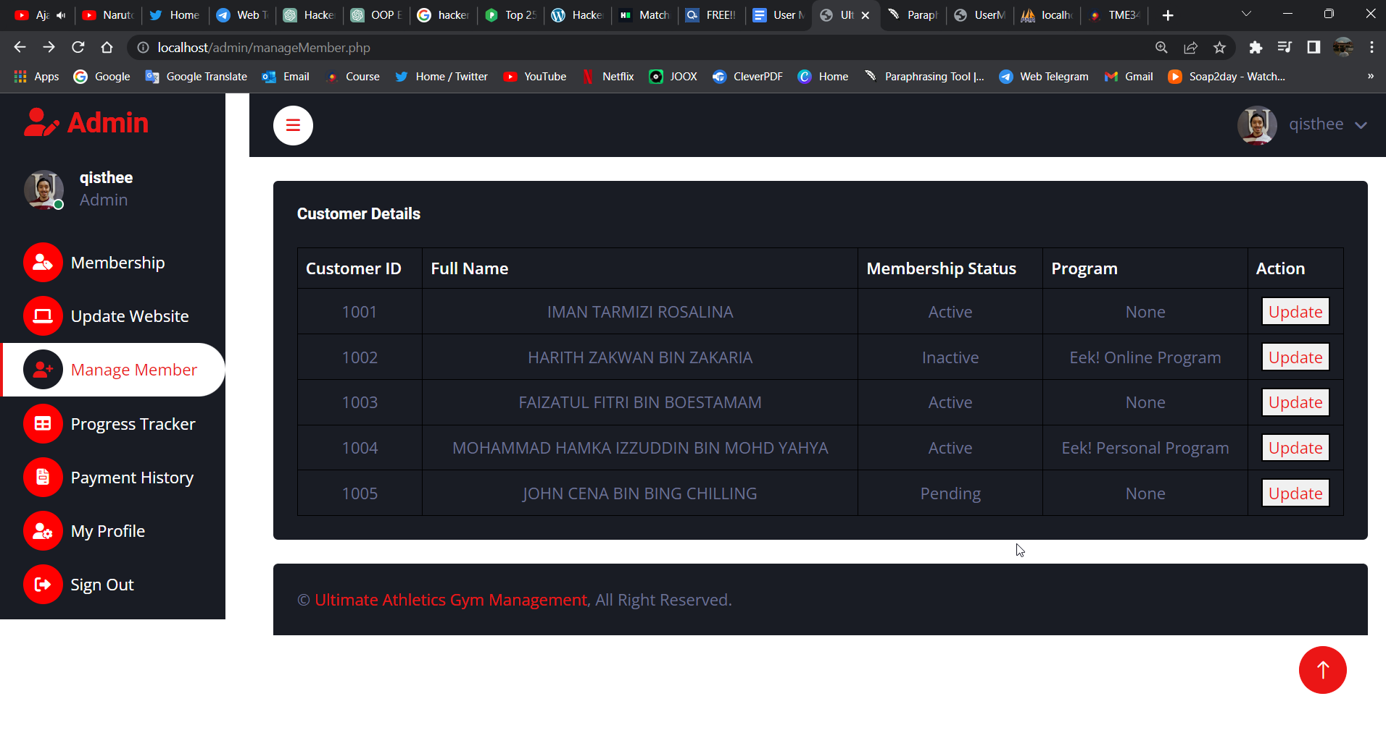

Figure 43: Manage Member - Customer Details

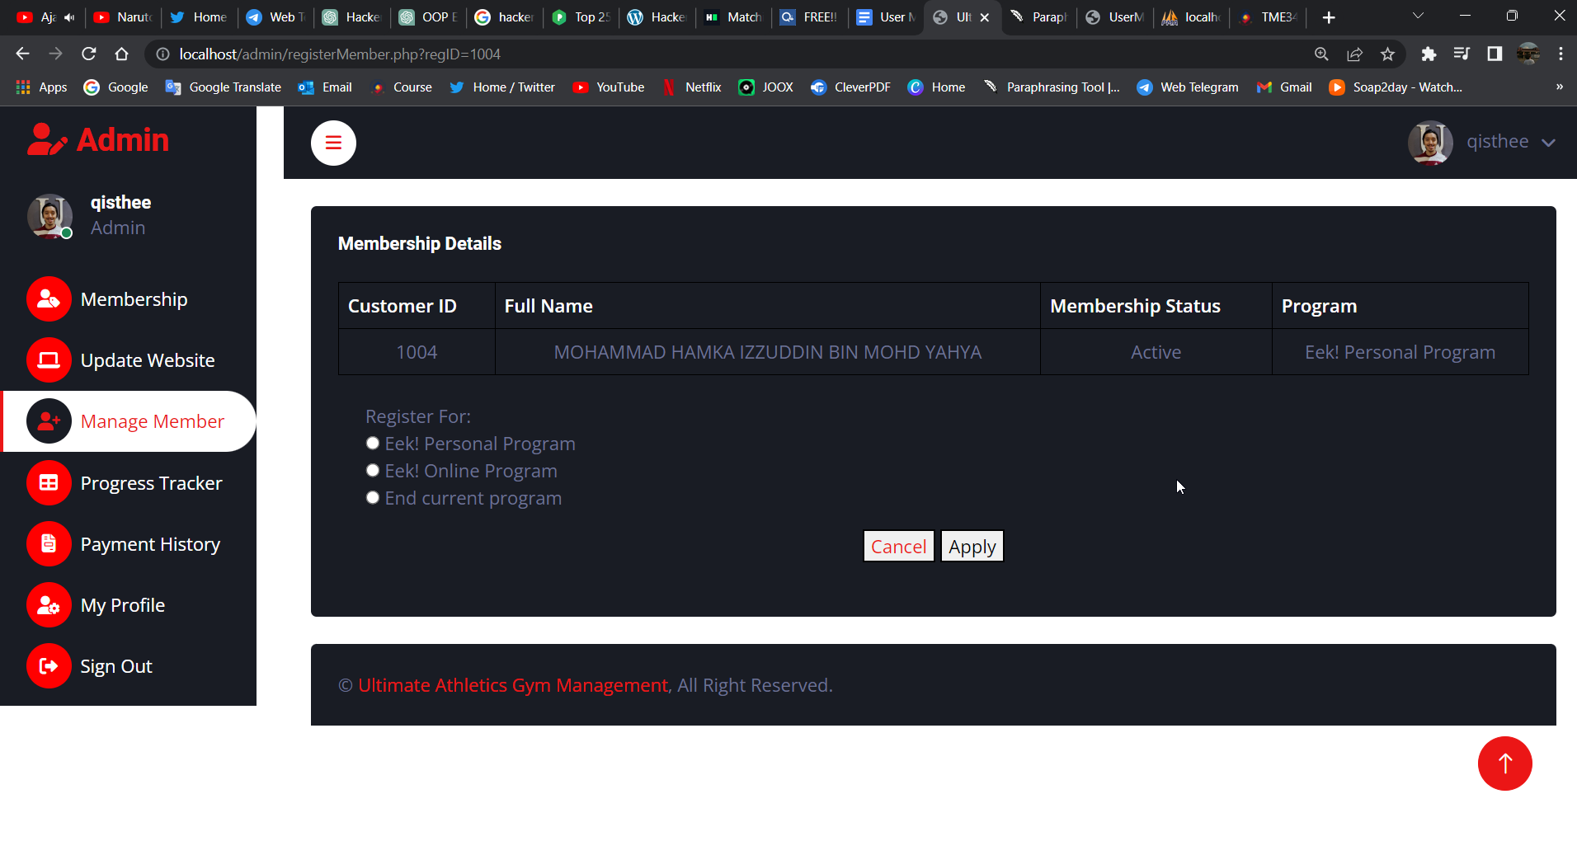

Figure 44: Manage Member - Membership Details

The Order History page shows all the customer’s order information such as order ID, Invoice No, Order date, Customer’s first and last name, address, email, phone number, product ordered, quantity, delivery method, delivery date, delivery time, additional order notes and the total order amount.

# 5.0 Progress Tracker

By selecting the Progress Tracker label and icon in the sidebar, the admin user may access the Progress Tracker page. The admin user will see a table of members and their programs once they are on the Progress Tracker page. From there, they can choose to view or edit the members' progress as necessary.

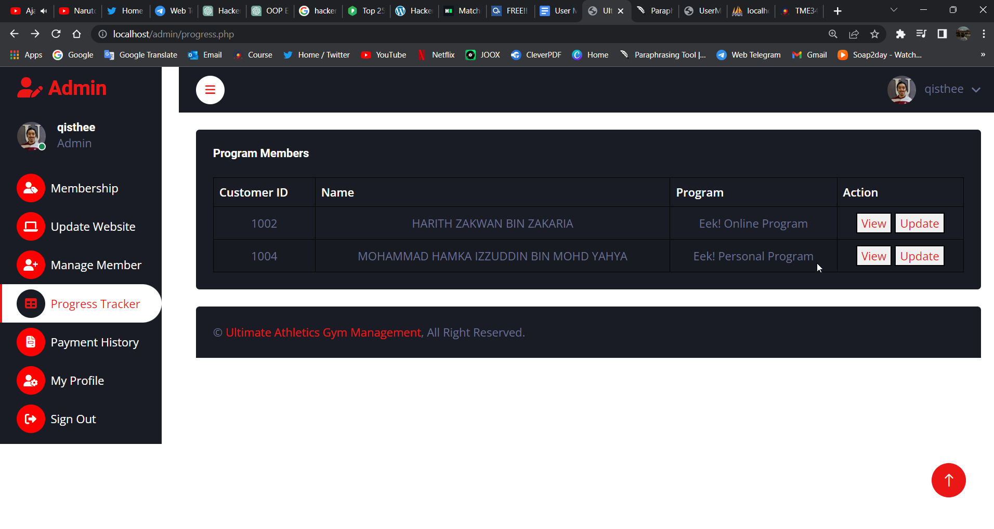

Figure 45: Progress Tracker Page

i) Progress Tracker Page (View)

Once the Admin user has chosen to view the program members they will be redirected to a page consisting of a sidebar menu, the same program members table on the previous progress tracker page, view session progression and view progress tracker table.

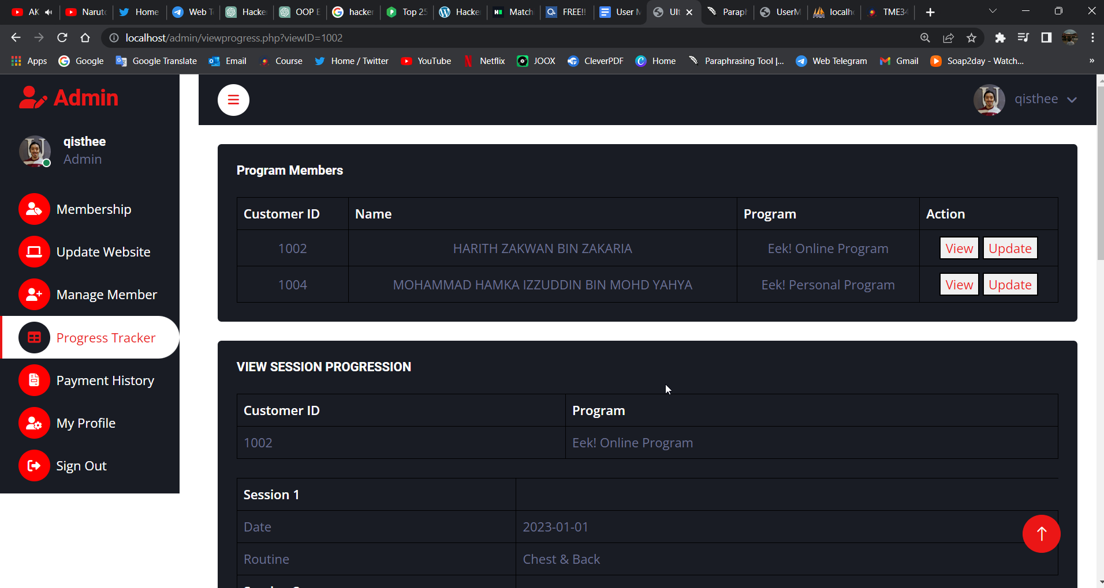

Figure 46: Progress Tracker Page (View) - Program Members Table

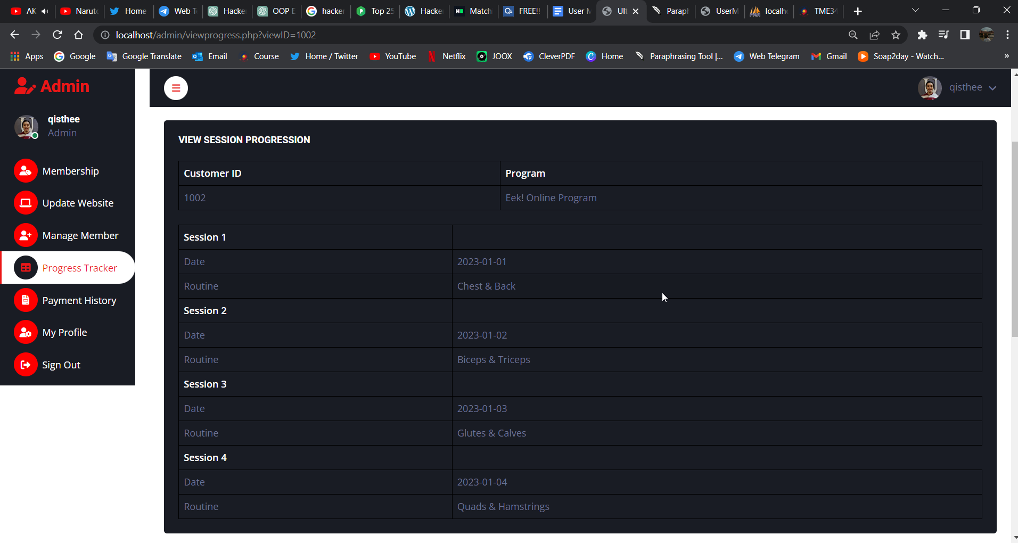

Figure 47: Progress Tracker Page (View) - View Session Progression Table

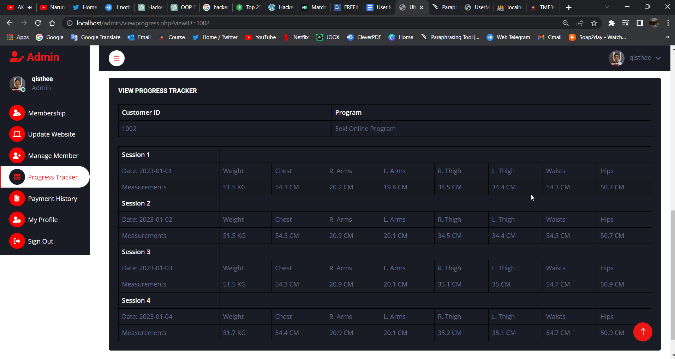

Figure 48: Progress Tracker Page (View) - View Progress Tracker Table

ii) Progress Tracker Page (Update)

When the Admin user chooses to update the program members, they are redirected to a page that includes a sidebar menu, the same program members table as on the previous progress tracker page but without a view and update button and only selected members are displayed, view session progression and view progress tracker tables, and a form to update both tables.

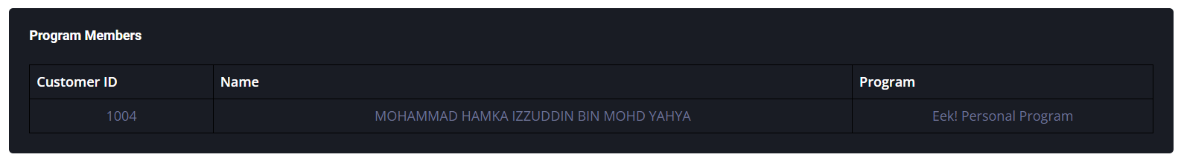

Figure 49: Progress Tracker Page (Update) - Program Members

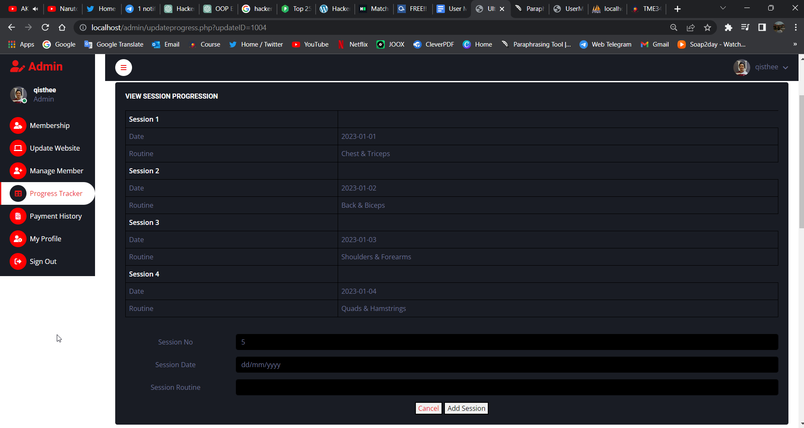

Figure 50: Progress Tracker Page (Update) - View Session Progression Table

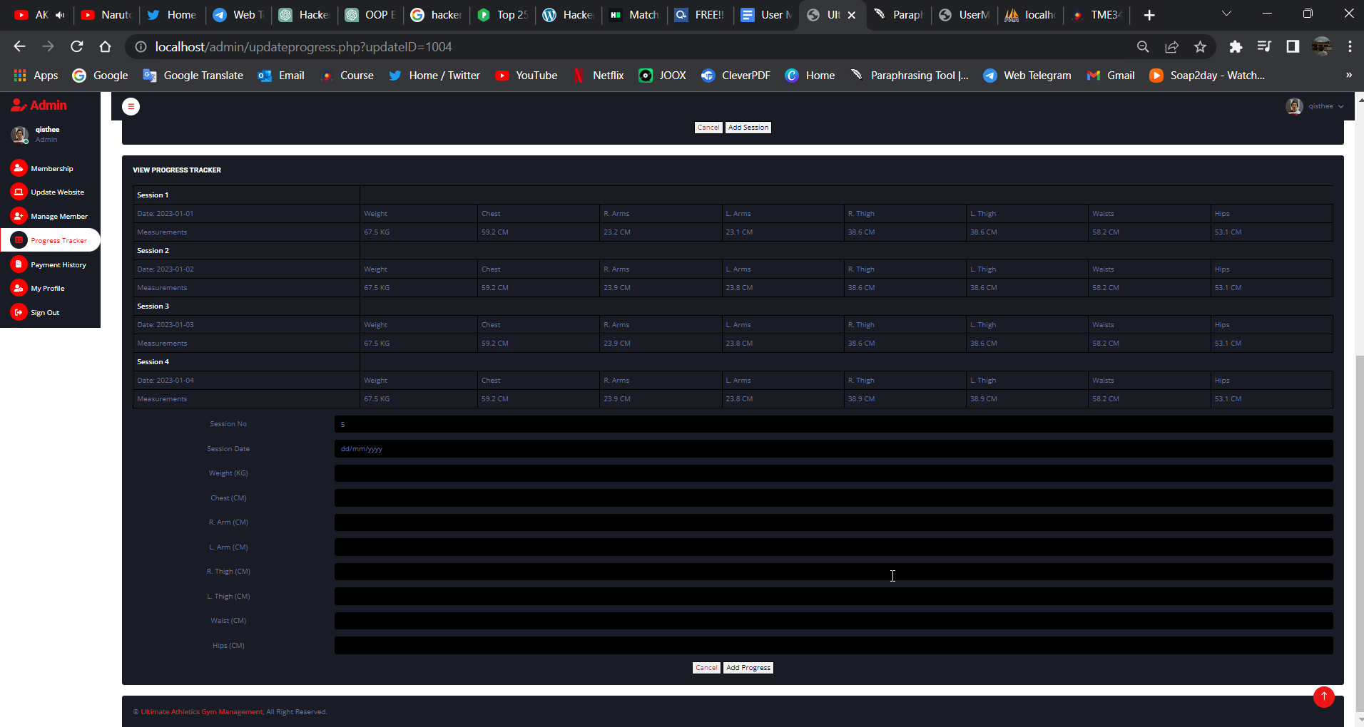

Figure 51: Progress Tracker Page (View) - View Progress Tracker Table

# 6.0 Payment History

# 

By selecting the Payment History label and icon in the sidebar, an administrator can see the Payment History Page. The admin user will be able to access all payment information from the database, including approved and outstanding payments, once they appear on the Payment History page.

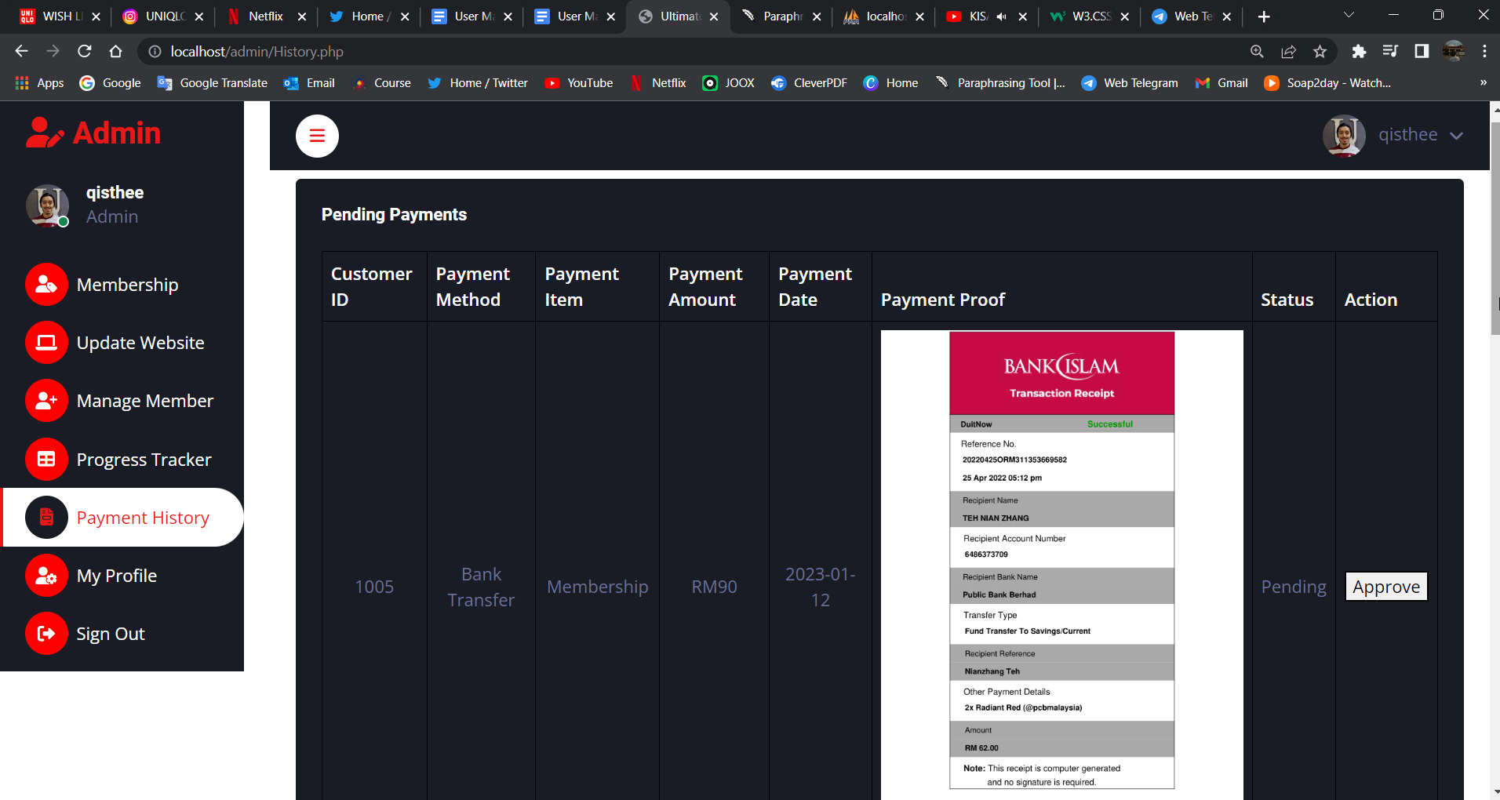

Figure 52: Payment History - Pending Payments

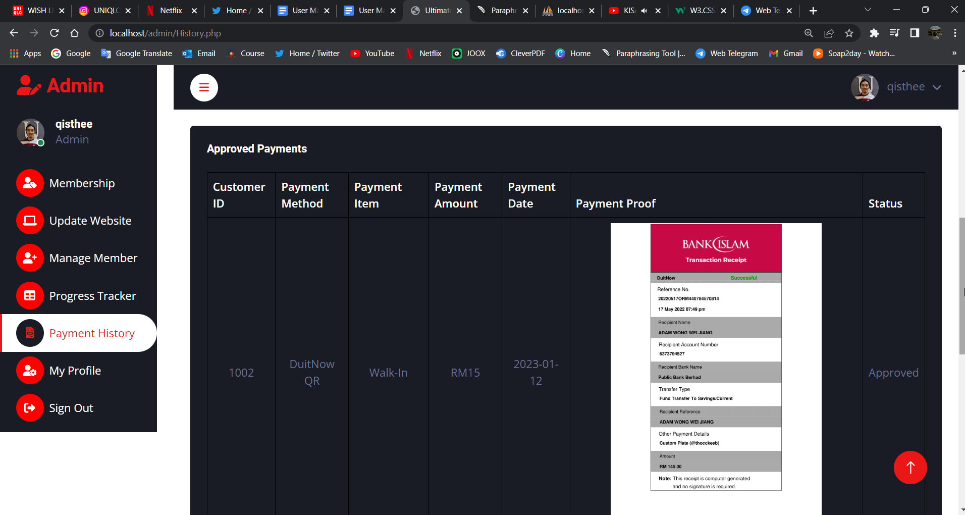

Figure 53: Payment History - Approved Payment

# 7.0 My Profile

The Admin User can also view and update their profile by clicking either on the right top profile icon or sidebar navigation menu.

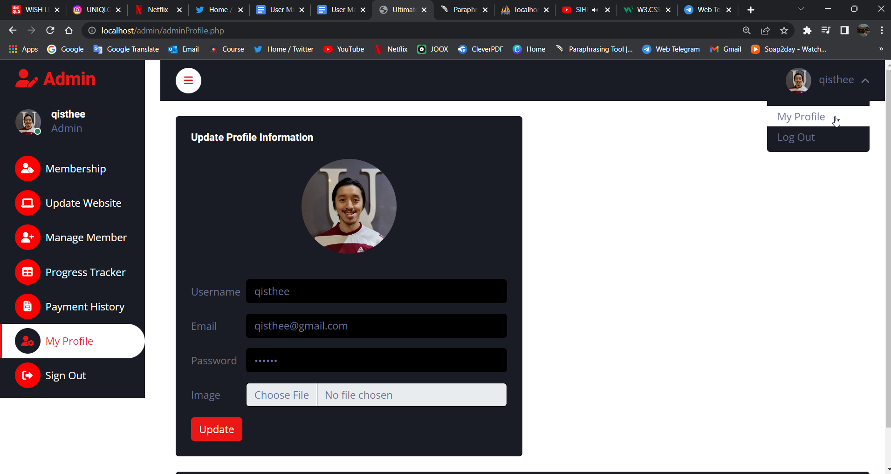

Figure 54: My Profile Navigation Option 1

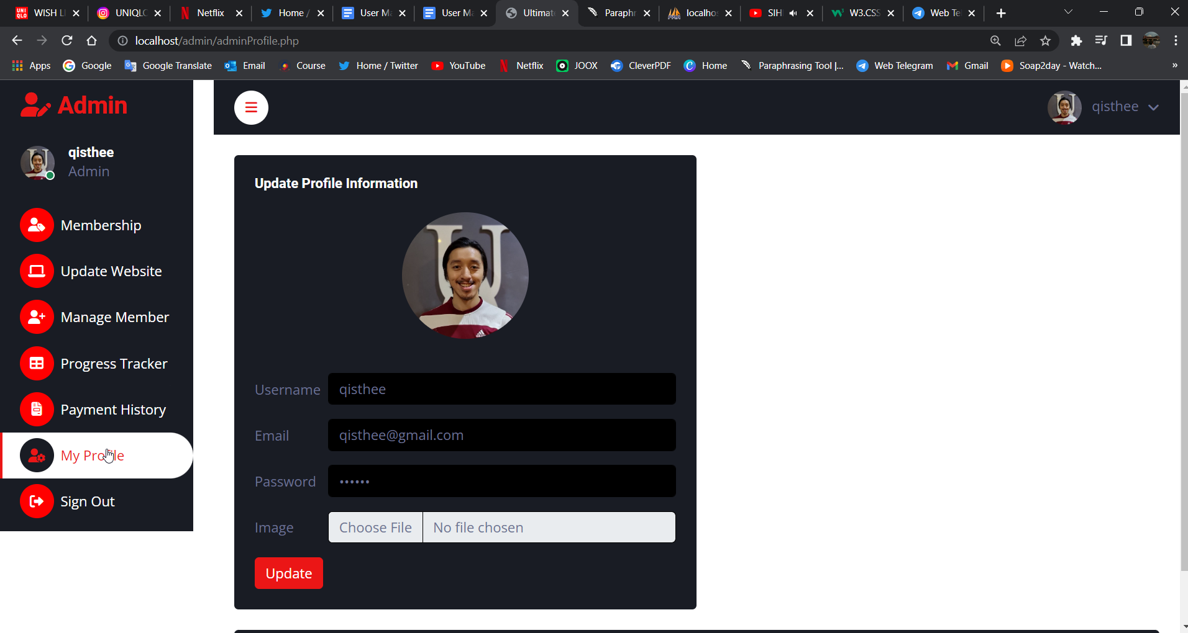

Figure 55: My Profile Navigation Option 2

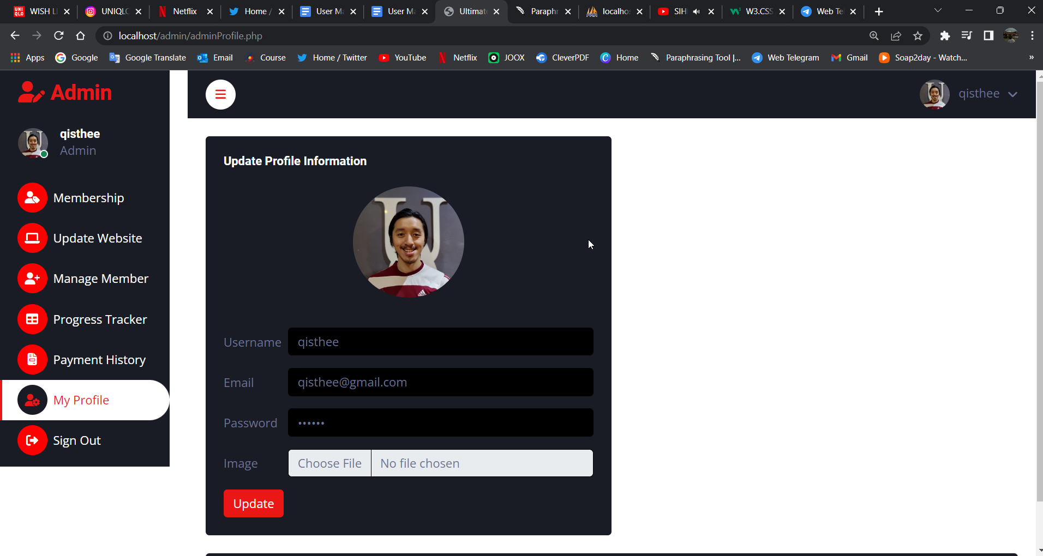

Figure 56: My Profile Page